Experiment 01
Aim: Demonstrate inline, internal, and external JavaScript; use console methods; create a webpage showing user info and a welcome message.
Software/Tools Required: HTML5, CSS3, JavaScript, VS Code , Google Chrome
Theory: JavaScript can be included in a web page using inline, internal, and external methods. Inline JavaScript is written directly within HTML elements, internal JavaScript is placed inside the
Output:
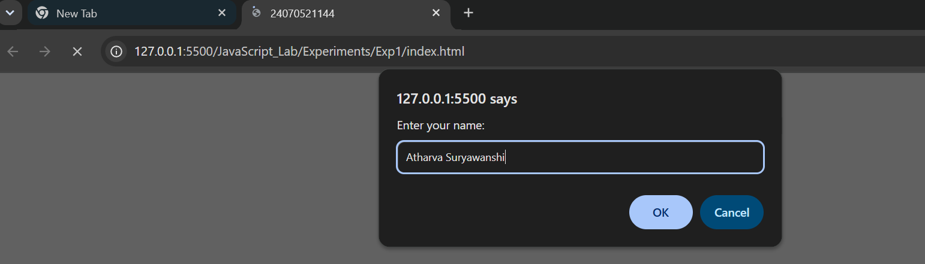
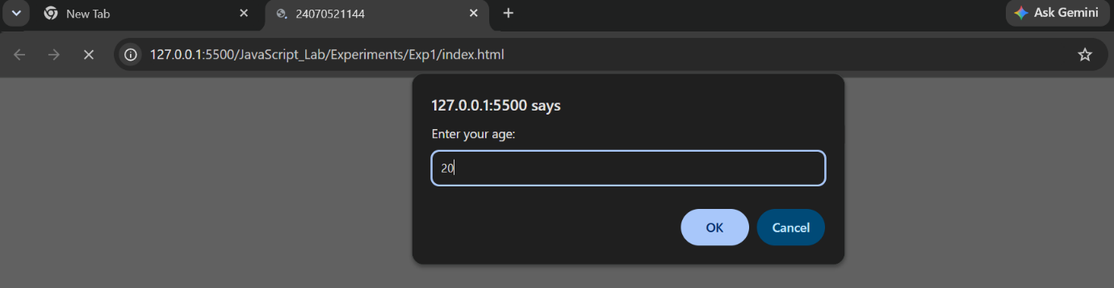
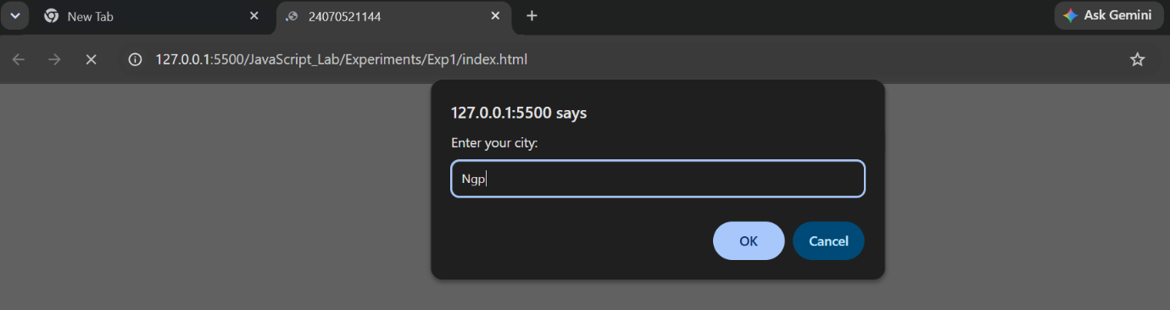
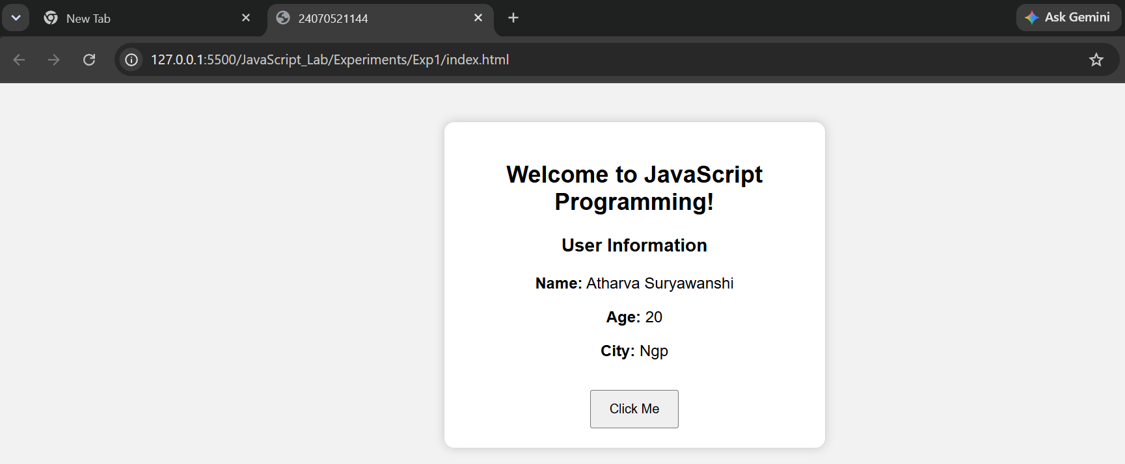
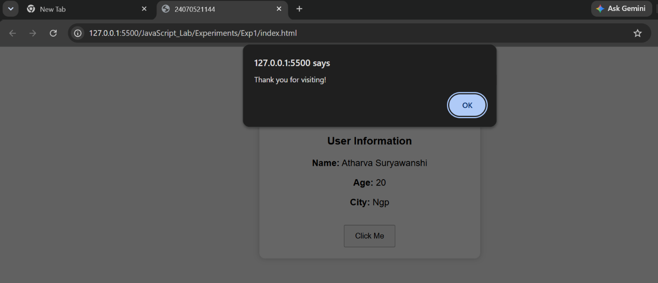

Result: The webpage was successfully created using inline, internal, and external JavaScript. It displayed a welcome message, accepted user information through input prompts, and demonstrated various console methods such as console.log(), console.info(), console.warn(), console.error(), and console.table() for debugging and output.

Case Study 01
Aim: Create a webpage for college department and link the student information page with it and write a javascript program to display “Welcome to SIT Nagpur” in an alert box.
Program Code:
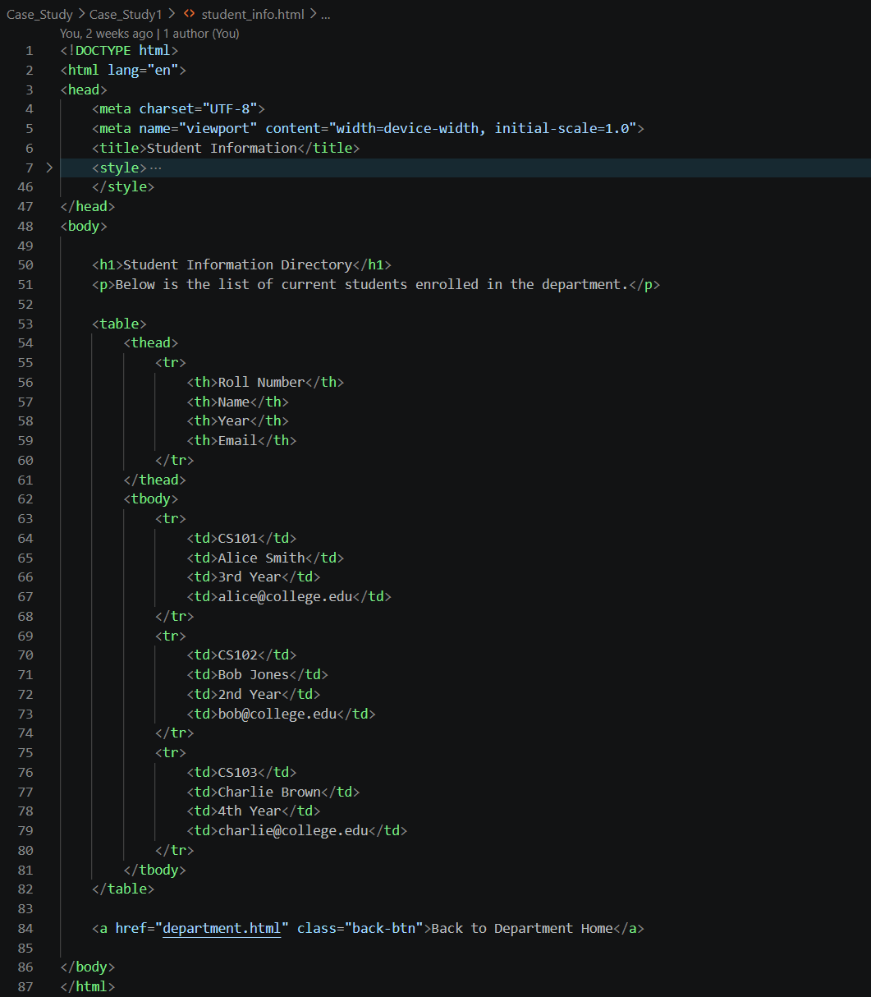

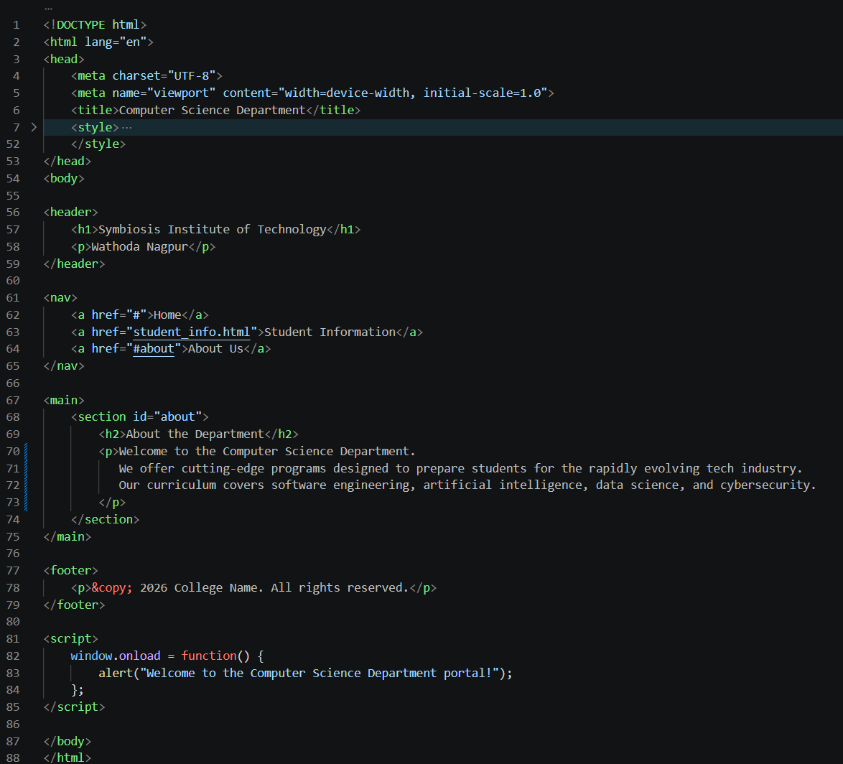
Output:
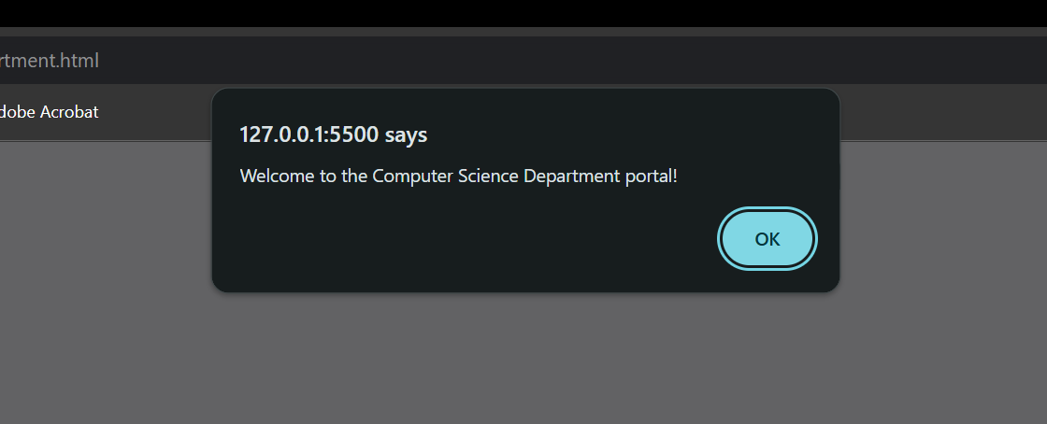
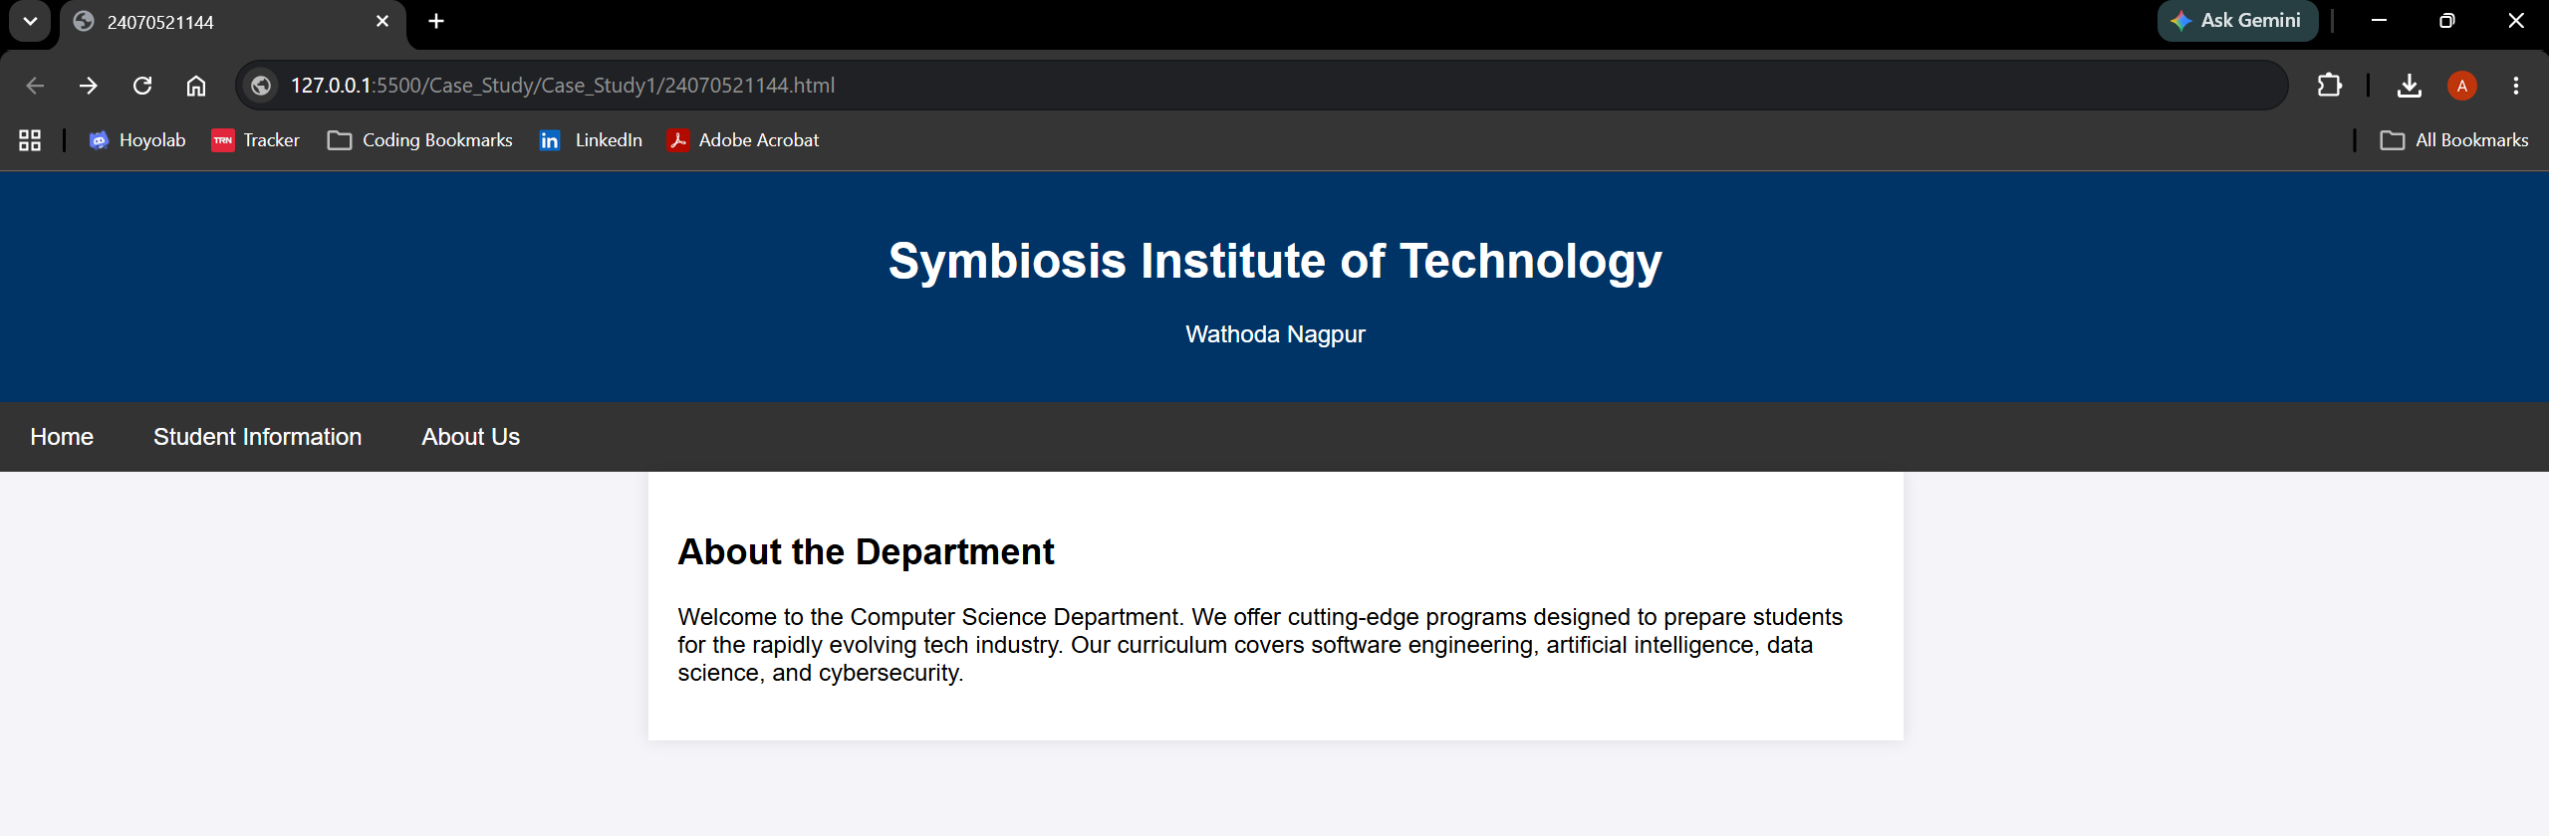

Result: A webpage for the college department was successfully created using HTML, CSS, and JavaScript. Student information was linked and displayed correctly, and the JavaScript program successfully displayed the message "Welcome to SIT Nagpur" on the webpage. Thus, the aim of creating a college department webpage and implementing JavaScript functionality was achieved successfully.

Experiment: 02
Aim: Use var, let, const, and demonstrate basic features like template literals and destructuring; build a billing calculator with user input.
Software/Tools Required: HTML5, CSS3, JavaScript, VS Code , Google Chrome
Theory: JavaScript provides var, let, and const for declaring variables with different scopes and behaviors. It also supports modern ES6 features such as template literals for easy string formatting and object destructuring for extracting object properties into variables. The prompt() function is used to accept input from the user. In this experiment, these features are used to develop a billing calculator that accepts product details, calculates the subtotal, GST (18%), and total amount, and displays a formatted bill dynamically on the web page.
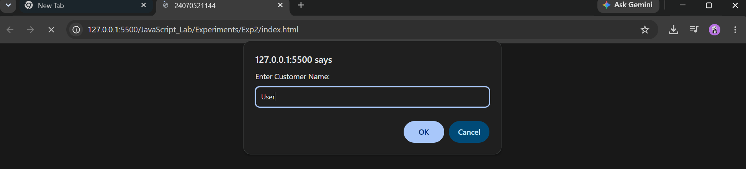
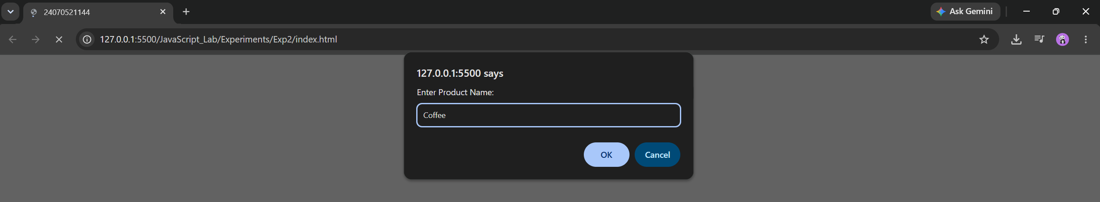
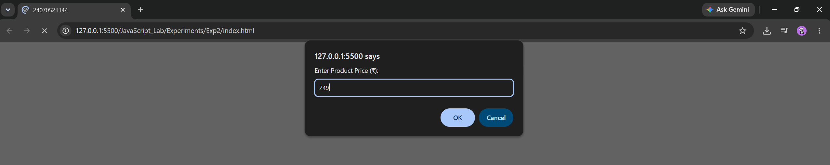
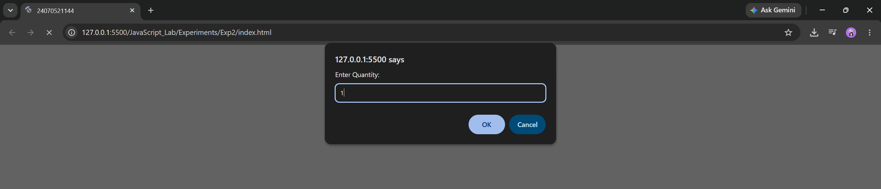

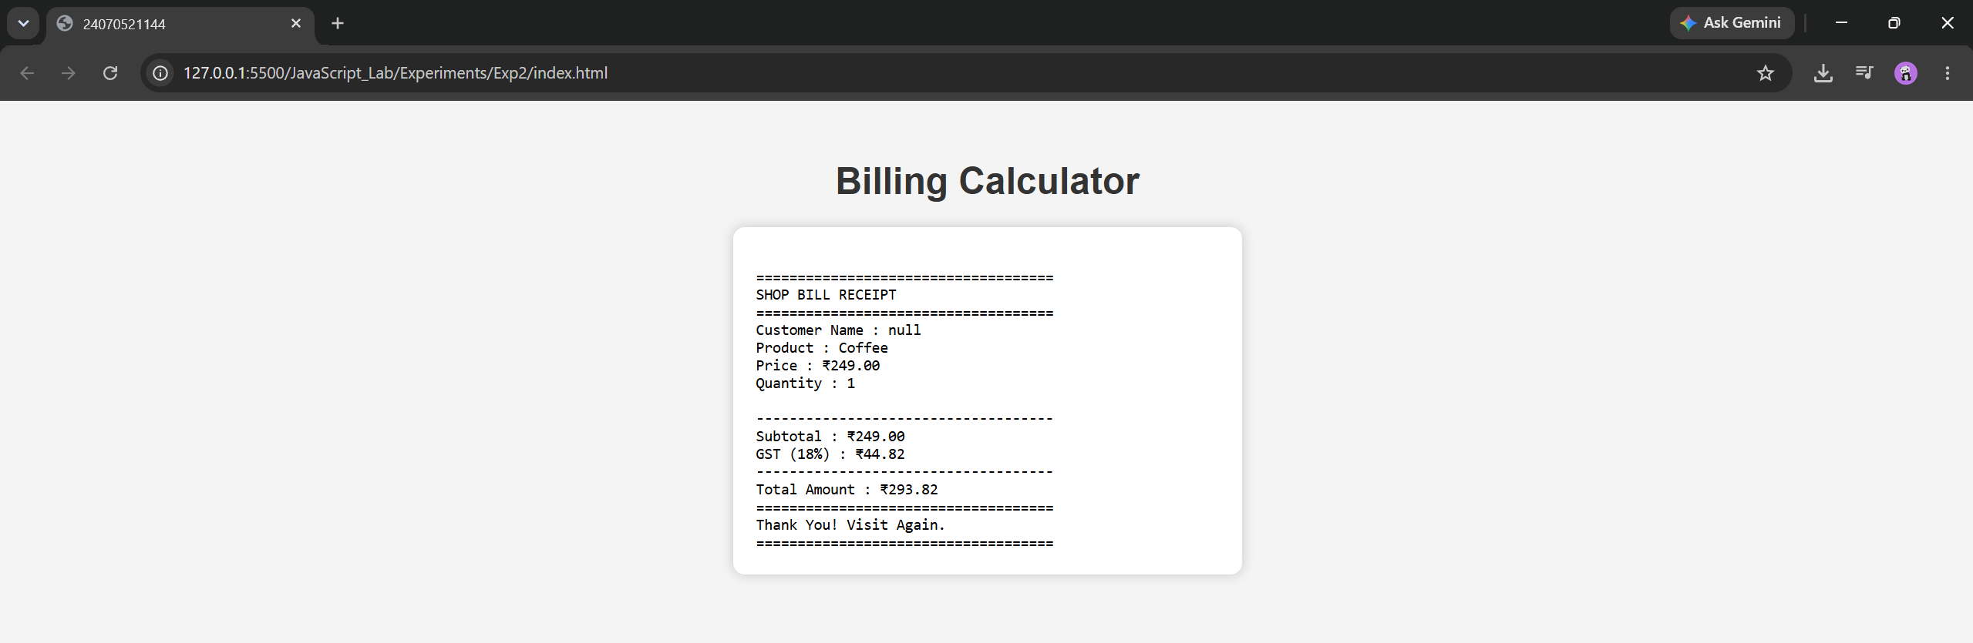

Result : The billing calculator was successfully developed using JavaScript. It accepted user input for the customer name, product details, price, and quantity, calculated the subtotal, GST (18%), and total amount, and displayed a well-formatted billing receipt on the web page.

Case Study 02
Aim: Develop the webpage for an inline shopping website with using html, css and html tags and calculate the bill, customer name, mobile number, invoice number, product number, quantity(kg), rate per kg, discount, GST, packing charges, payment mode(cash/card/UPI), membership(yes/no)
Program Code:
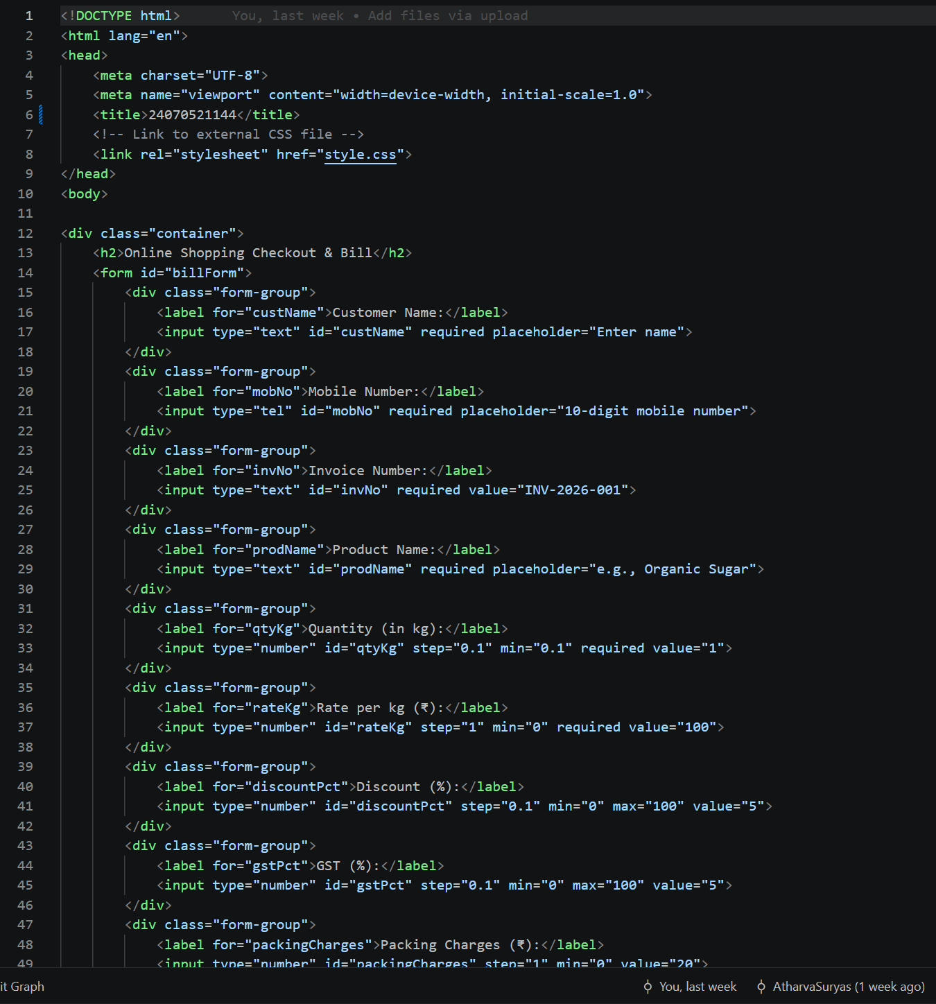

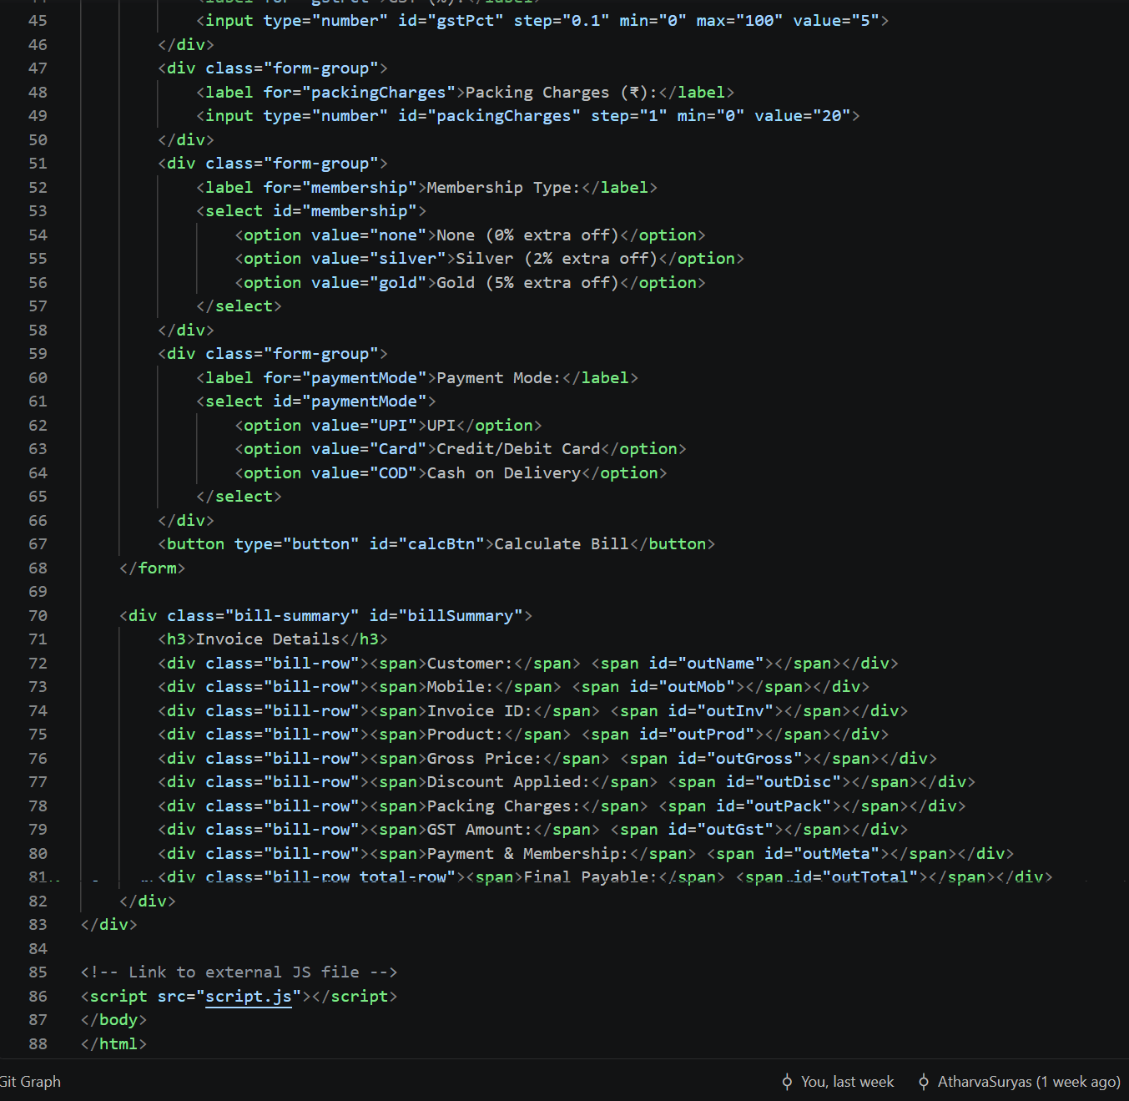

Output:
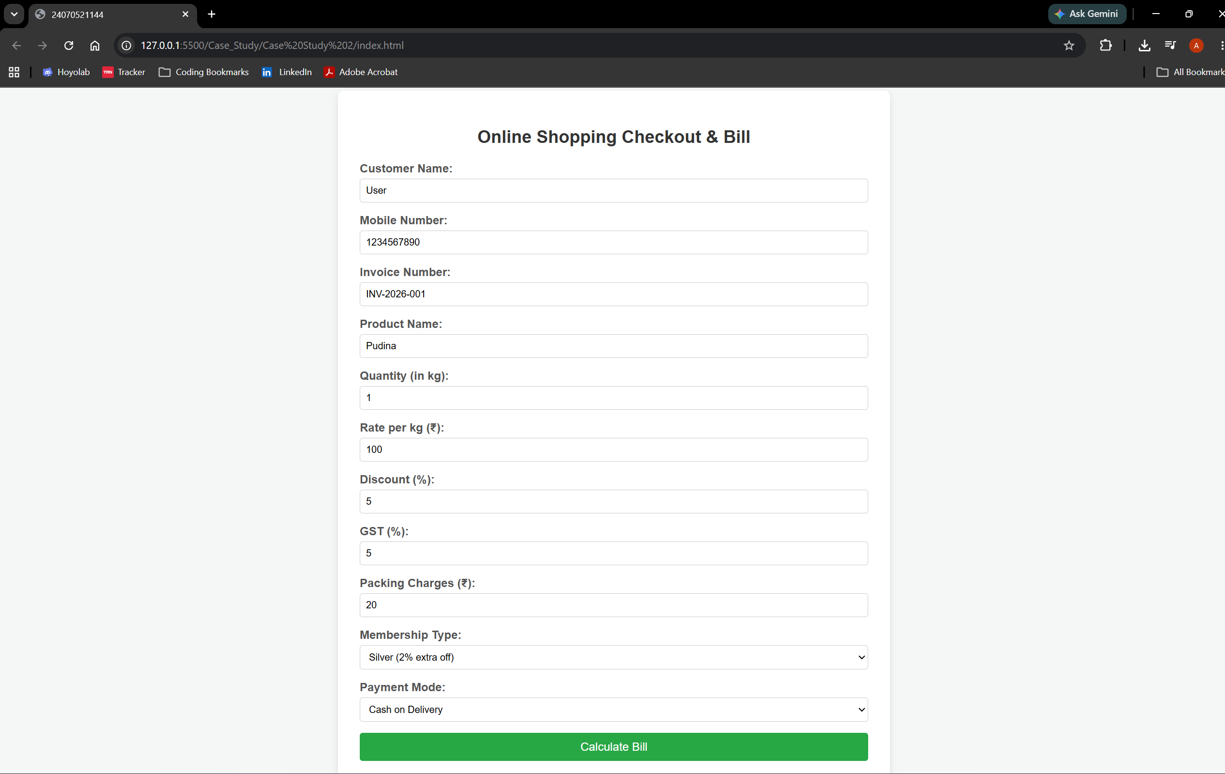
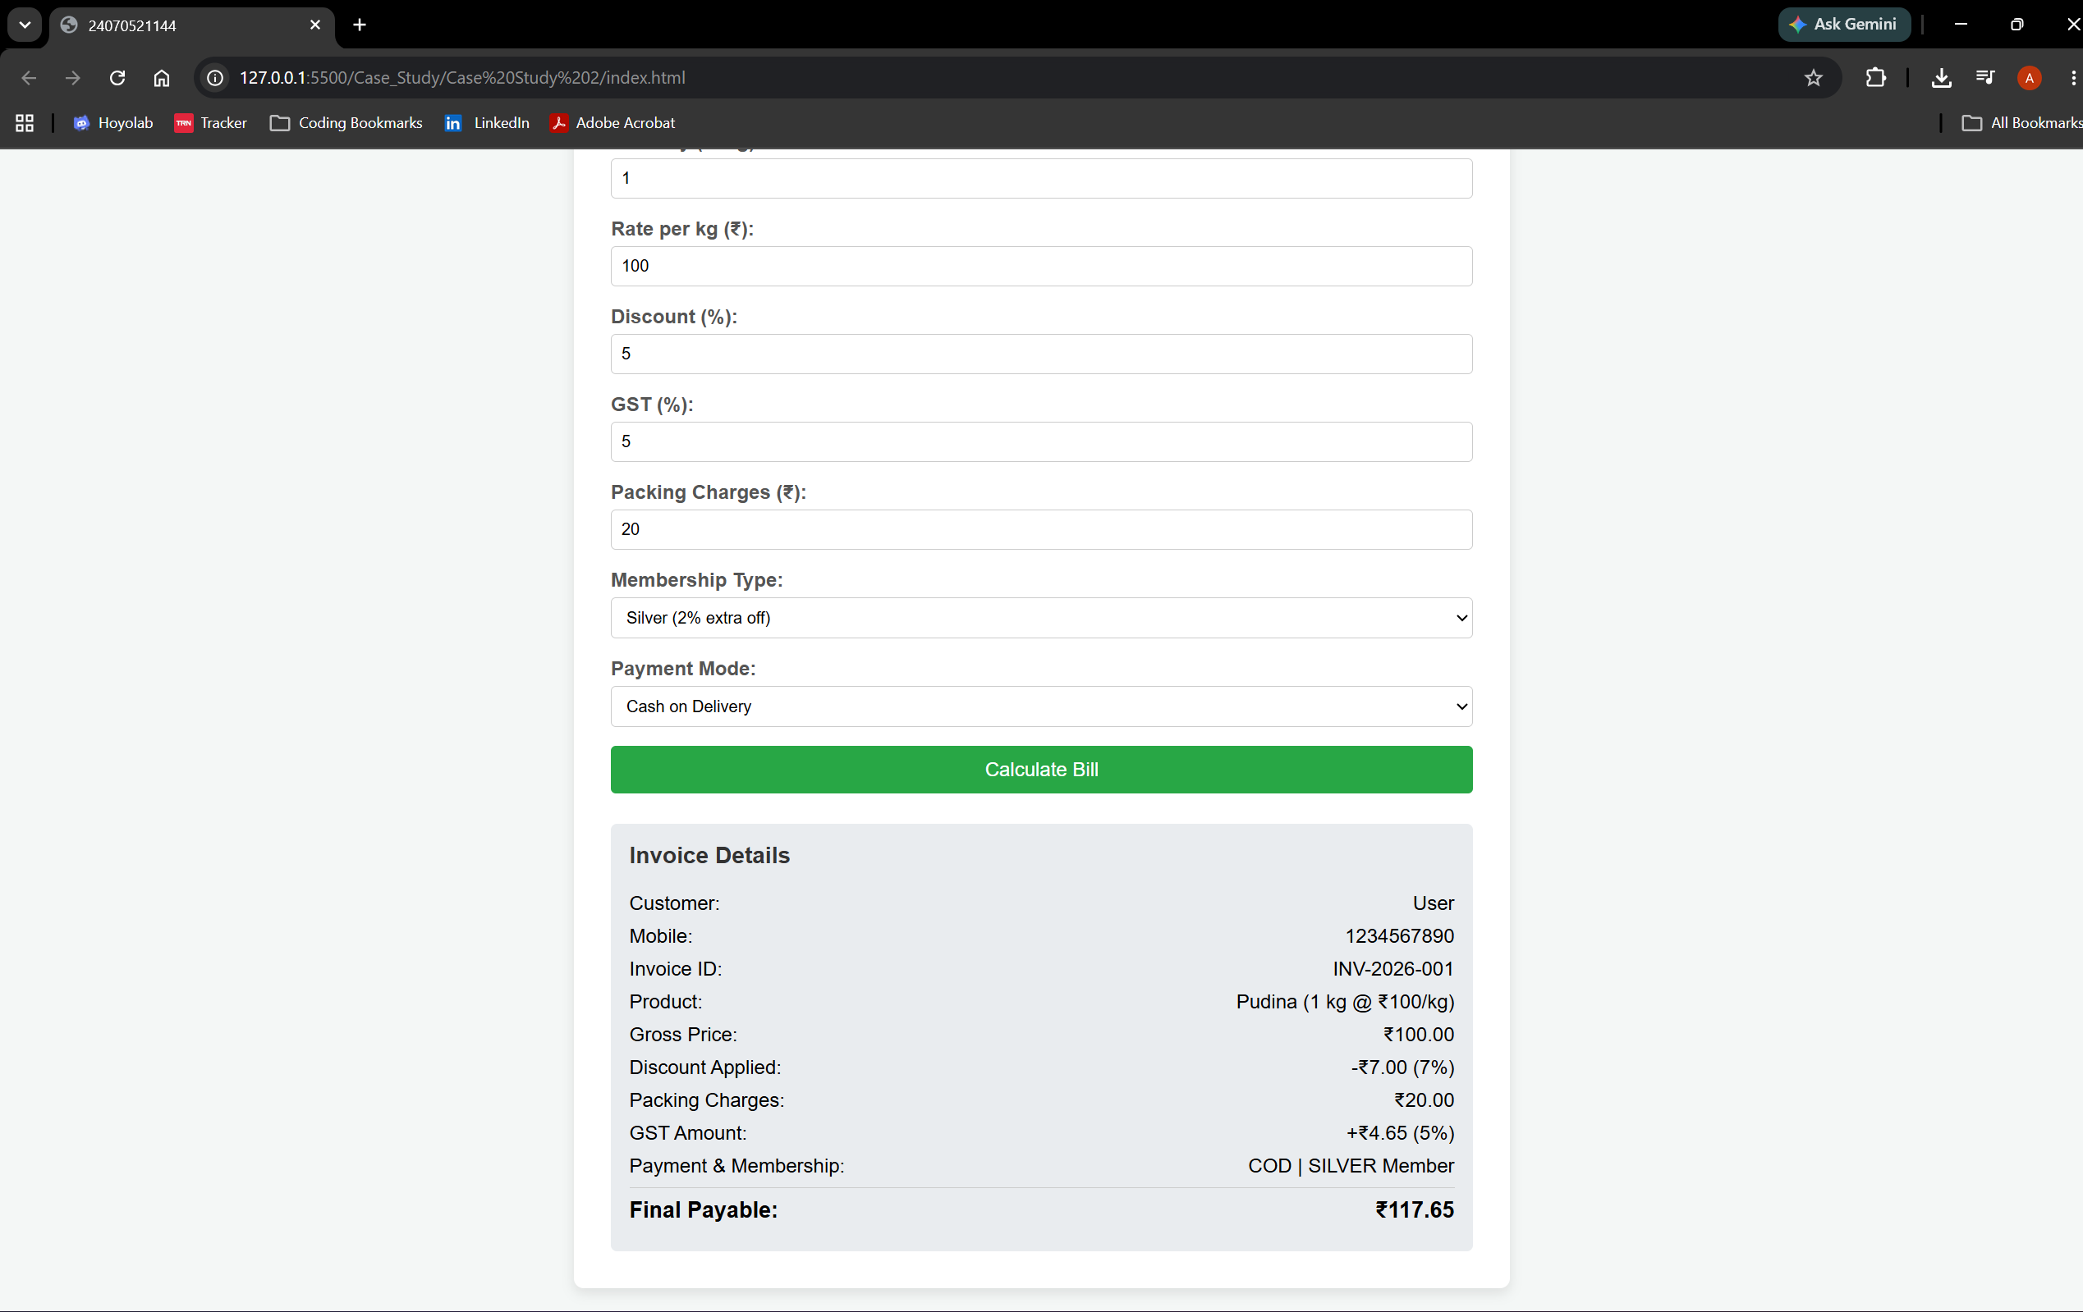

Result: The online shopping billing webpage was successfully developed using HTML, CSS, and JavaScript. The program accepted customer and product details, calculated the total bill including discount, GST, and packing charges, and displayed the final invoice correctly. It demonstrated the use of user input, arithmetic calculations, objects, template literals, and object destructuring in JavaScript.

Experiment No: 03
Aim: Implement control structures and form validation, create a grading system based on user entered marks
Software/Tools Required: HTML5, CSS3, JavaScript, VS Code , Google Chrome
Theory: JavaScript provides essential control structures, including conditional statements (if, else if, else, and switch) and loops (for, while, and do-while), to manage program execution based on dynamic conditions. These structures enable developers to build interactive features such as form validation, which checks and sanitizes user input on the client side before submission to prevent invalid or incomplete data. Additionally, JavaScript interacts with DOM elements to extract input values, process business logic—such as evaluating numeric ranges to assign grades—and dynamically display results on the web page. In this experiment, control structures and form validation techniques are applied to capture student marks, validate the input, dynamically calculate a grade, and display the formatted outcome to the user.

Output:
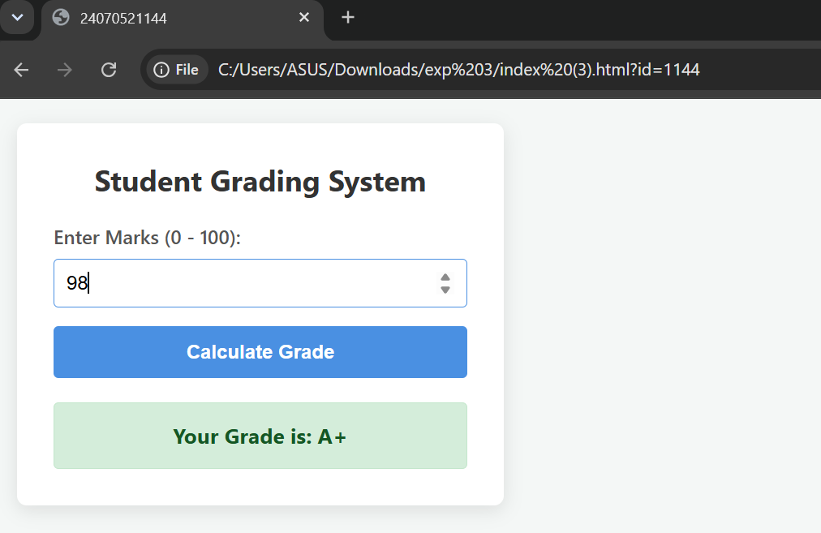

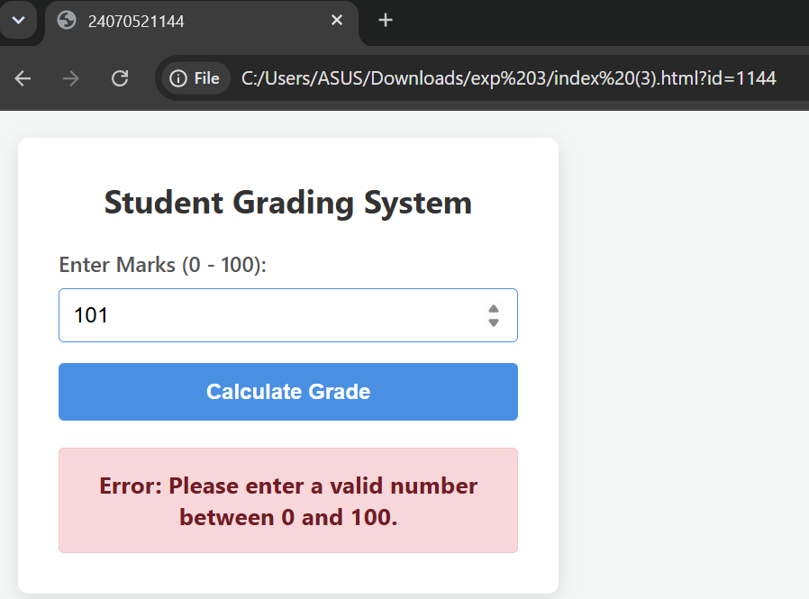

Result:
The JavaScript-based control structures and form validation system were successfully implemented and tested. The application correctly validates user-entered marks, ensuring input fields are non-empty, numeric, and fall within the valid range of $0$ to $100$. Upon validation, the control logic evaluates the entered score against predefined grading criteria and dynamically displays the corresponding grade along with feedback directly on the web page.

Case Study 03
Aim: Scholarship Eligibility,A college awards scholarships based on marks. Below 50-Not Eligible, 50-69-Bronze,70-84-Silver,85-94-Gold,95-100-Platinum.
Program Code:
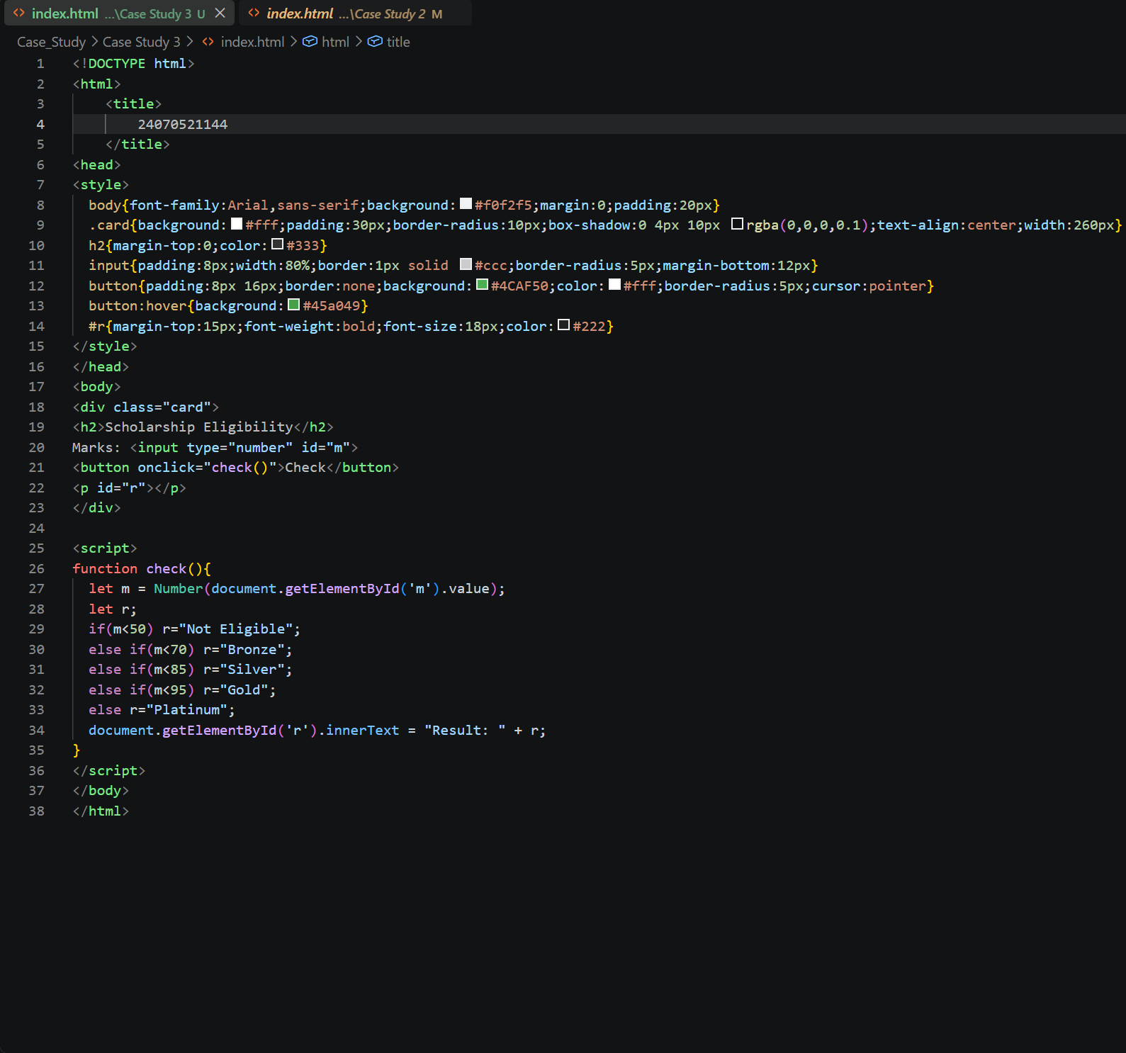

Output:
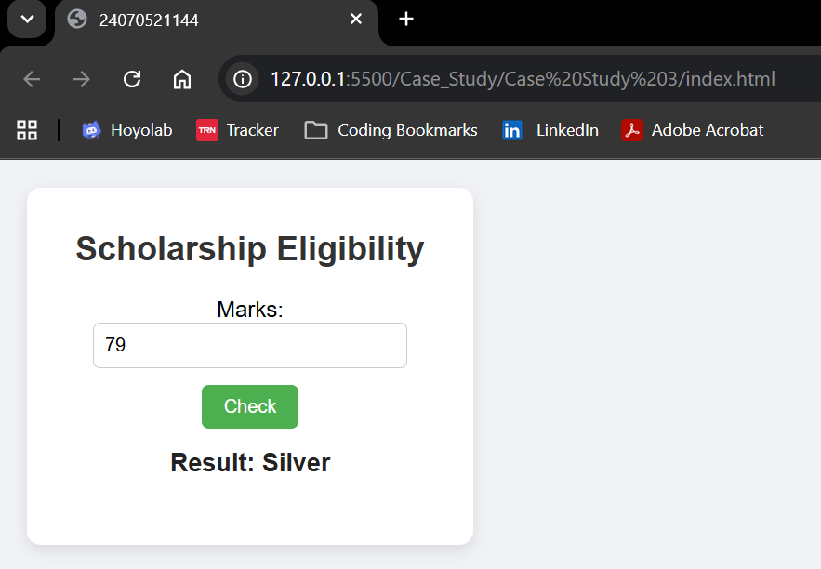

Result: The Scholarship Eligibility was successfully implemented using JavaScript. The program validated the user input, assigned eligibility marks using if-else control structures, and displayed the correct Eligibility awards based on the entered marks. It effectively demonstrated the use of control structures and form validation in web development.

Experiment 04
Aim: Use function types, scope and closures; apply try-catch; build a palindrome checker
Software/Tools Required: HTML5, CSS3, JavaScript, VS Code , Google Chrome
Theory: A palindrome is a word, number, or sentence that reads the same forward and backward, such as MADAM, LEVEL, and 121. A palindrome checker is a program that checks whether the given input is a palindrome or not by comparing the original string with its reverse.
In JavaScript, different types of functions, such as function declarations, function expressions, and arrow functions, can be used to implement the palindrome checker. Variable scope determines where variables can be accessed in the program, while closures allow an inner function to access variables from its outer function.
The try-catch statement is used for exception handling and helps manage errors, such as invalid or empty input, without stopping the execution of the program. Thus, a palindrome checker demonstrates the concepts of functions, scope, closures, and error handling in JavaScript.
Output:
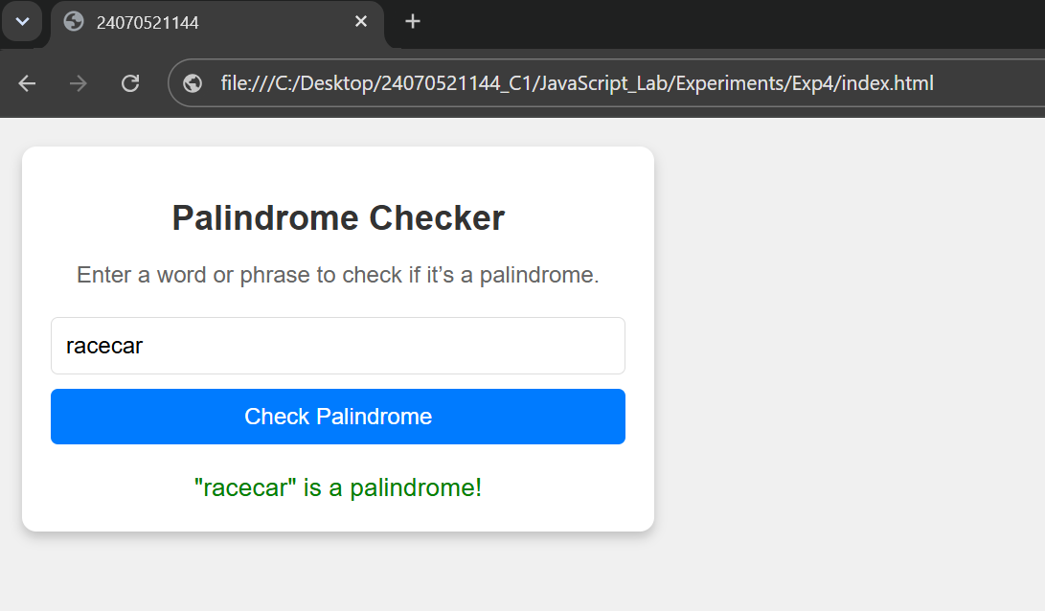

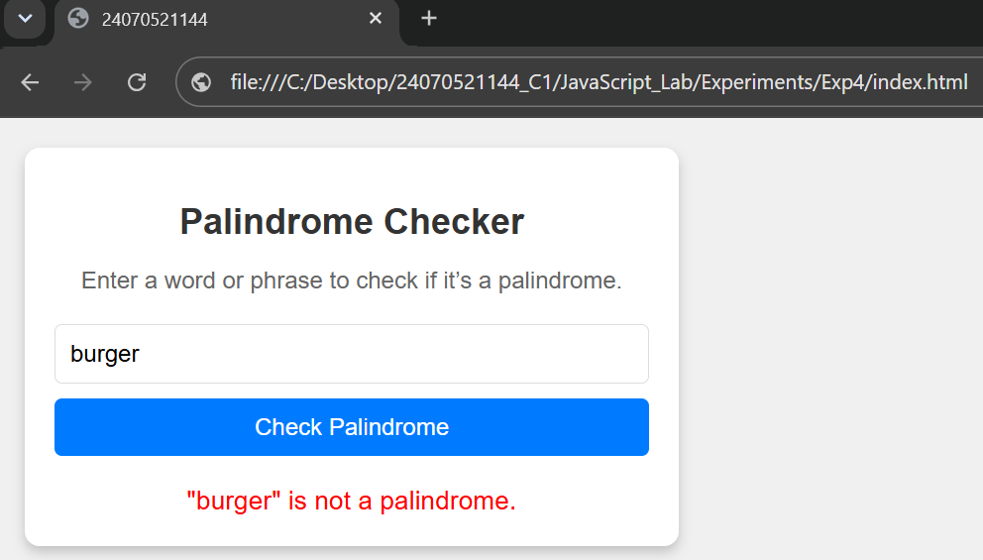

Result: Successfully implemented a Palindrome detector using JavaScript ES6 features, including var, let, const, template literals, and destructuring, to find and display whether the given text or number is a palindrome or not.

Case Study 04
Aim: The ATM system verifies if the pin is palindrome. If the palindrome displays a security message. To implement this create a function to reverse the entered pin number and another function to check if it is palindrome. use function declaration, function expression, arrow function and demonstrate scope and closure concepts.
Program Code:
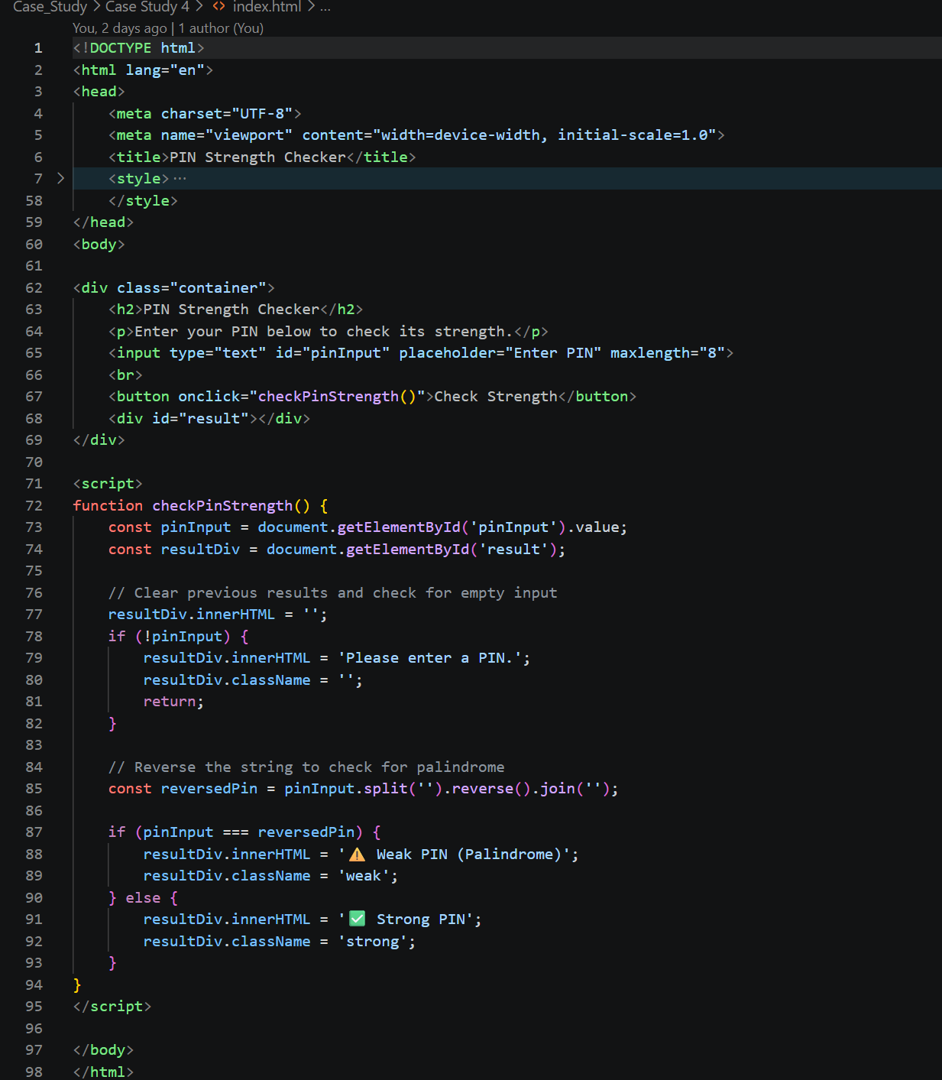
Output:
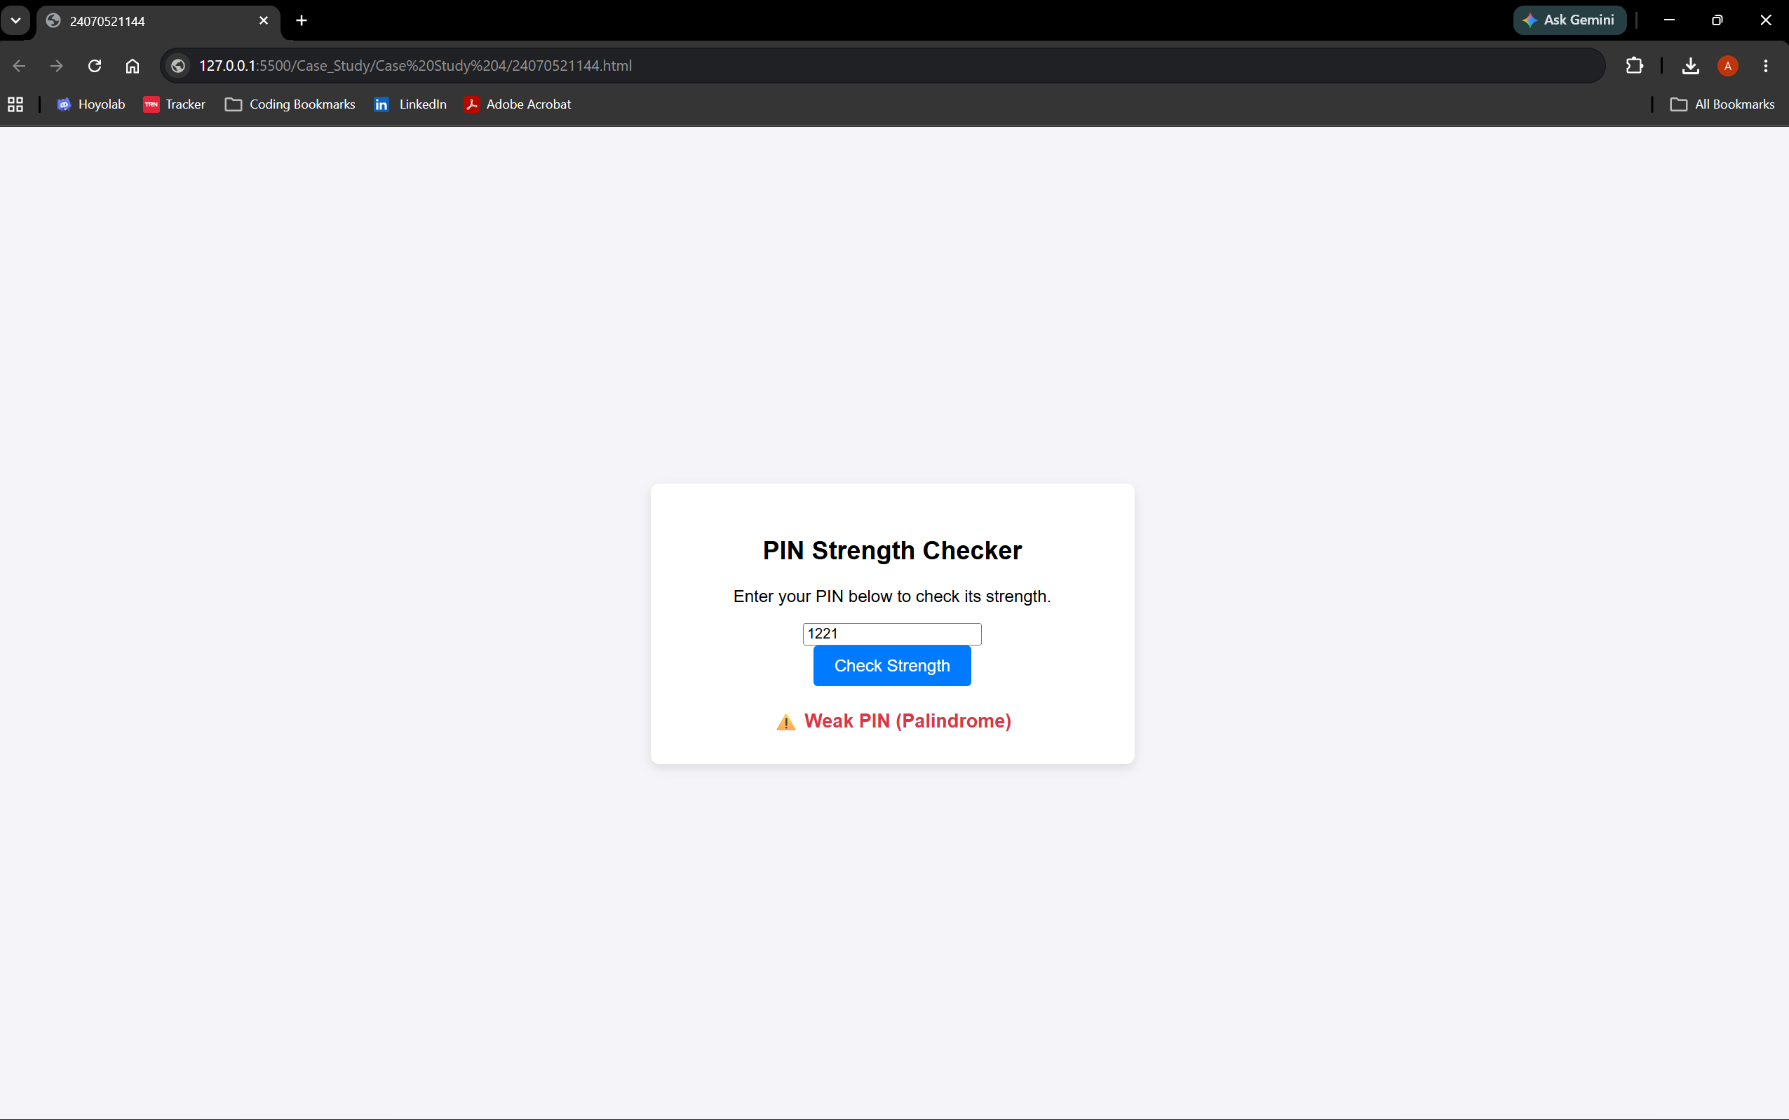

Result: Successfully implemented a ATM pin Palindrome detector using JavaScript ES6 features, including var, let, const, template literals, and destructuring, to find and display whether the given ATM pin is a palindrome or not.

Experiment 05
Aim: Apply array methods and object handling, create a cart total calculator with discount logic
Theory: JavaScript provides high-order array methods and object manipulation capabilities to model real-world data structures efficiently. Objects allow grouping related key-value pairs—such as product names, prices, and quantities—into structured data models. Native JavaScript array methods like .map() transform dataset arrays into dynamic visual representations (such as HTML table rows), .filter() creates new arrays by excluding specific elements (enabling item deletion), and .reduce() aggregates multi-item values into a single total amount. Additionally, control logic can be chained with these calculations to dynamically evaluate threshold conditions—such as applying tiered percentage discounts based on total order values. In this experiment, these concepts are combined to build a shopping cart calculator that processes item object arrays, evaluates tier-based discount rules, and updates the final payable amount on the DOM in real time.
Output:
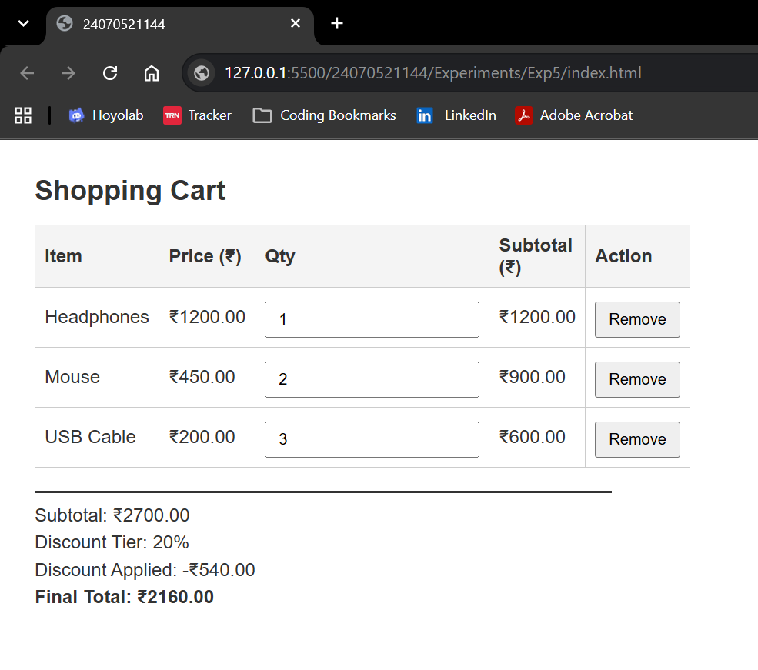

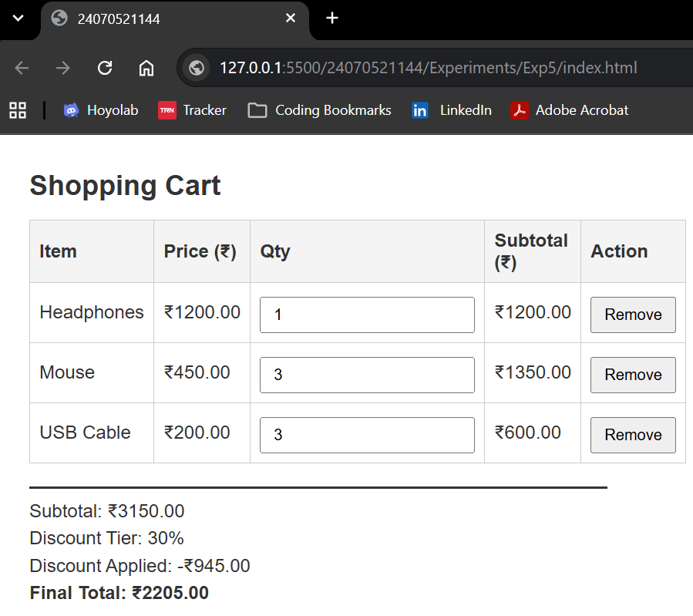

Result:
The shopping cart total calculator was successfully implemented using JavaScript array methods (.map(), .filter(), .reduce()) and object handling. The application accurately computes cart subtotals, handles item removal, and applies slab discounts (10% at ₹1,000, 20% at ₹2,000, and 30% at ₹3,000+) to update the final total in real time.
Conclusion:
This experiment highlights how array methods and object-oriented data structures simplify data manipulation and aggregation in JavaScript. Combining these methods with conditional discount logic enables efficient client-side calculations and dynamic DOM updates for interactive web applications.

Case Study 05
Aim:

Program Code:
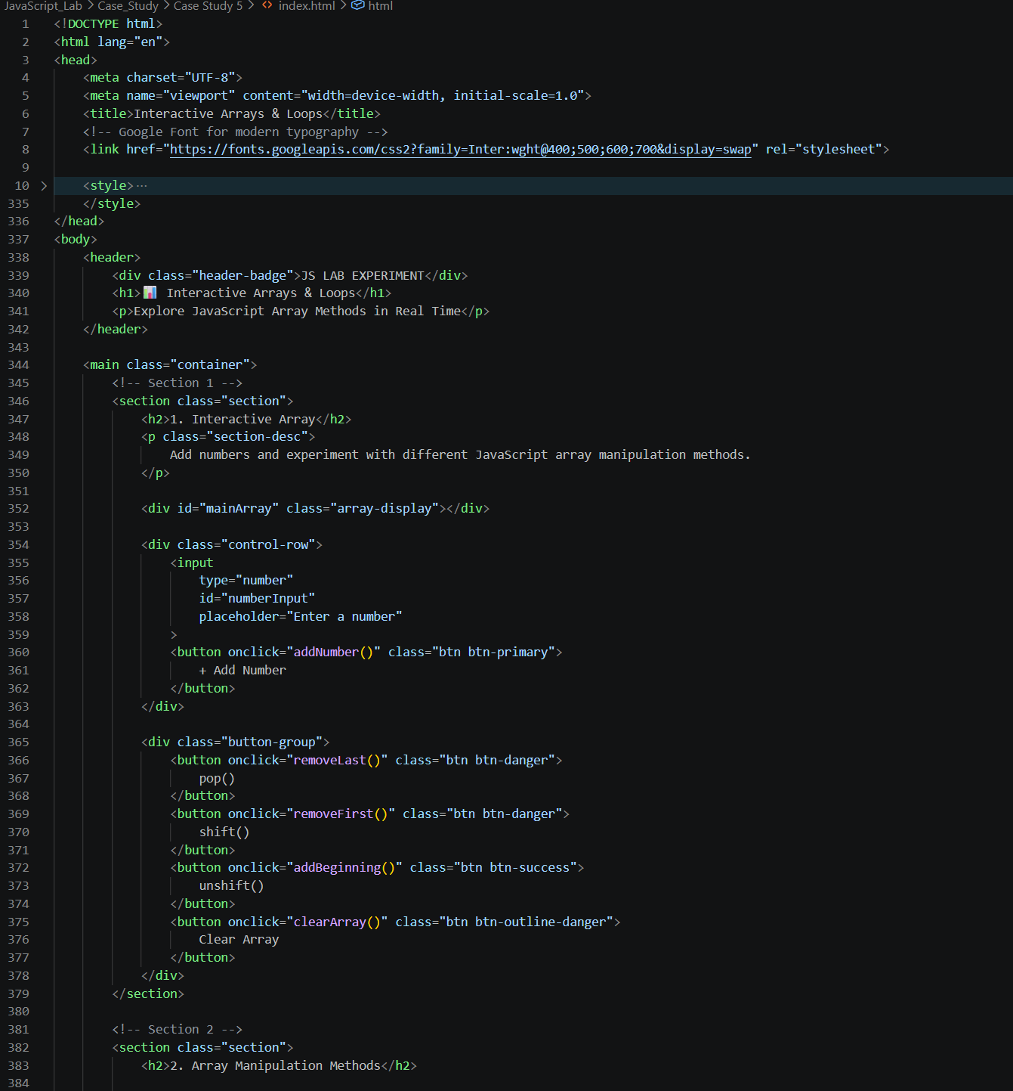

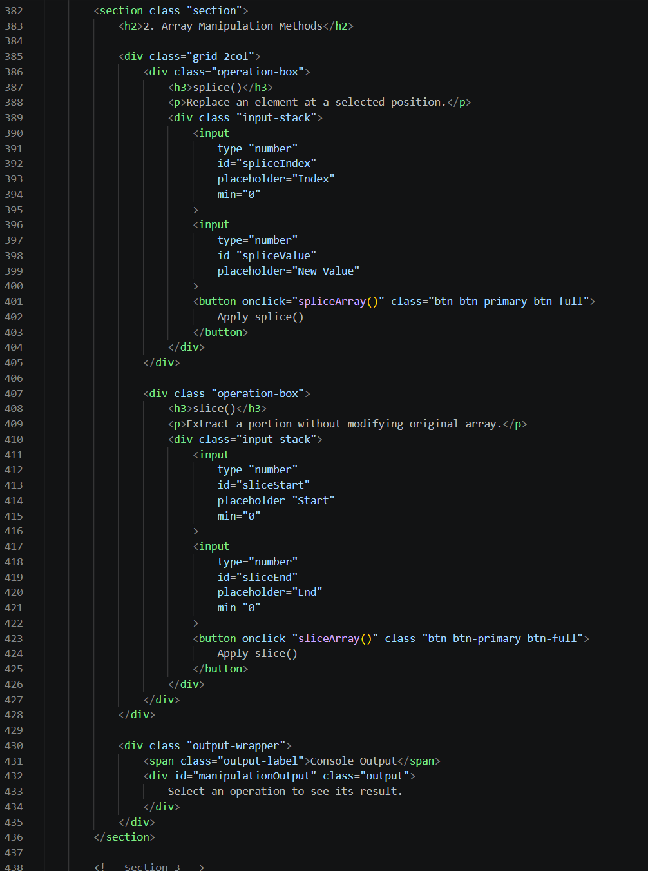

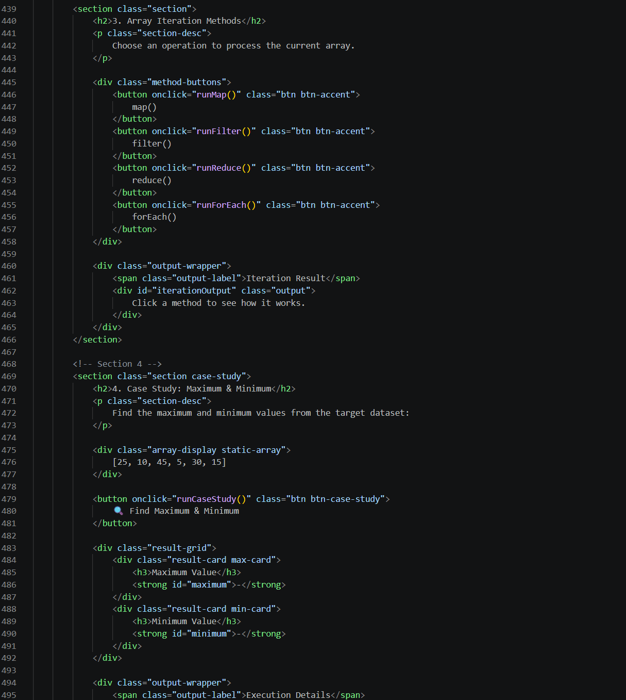

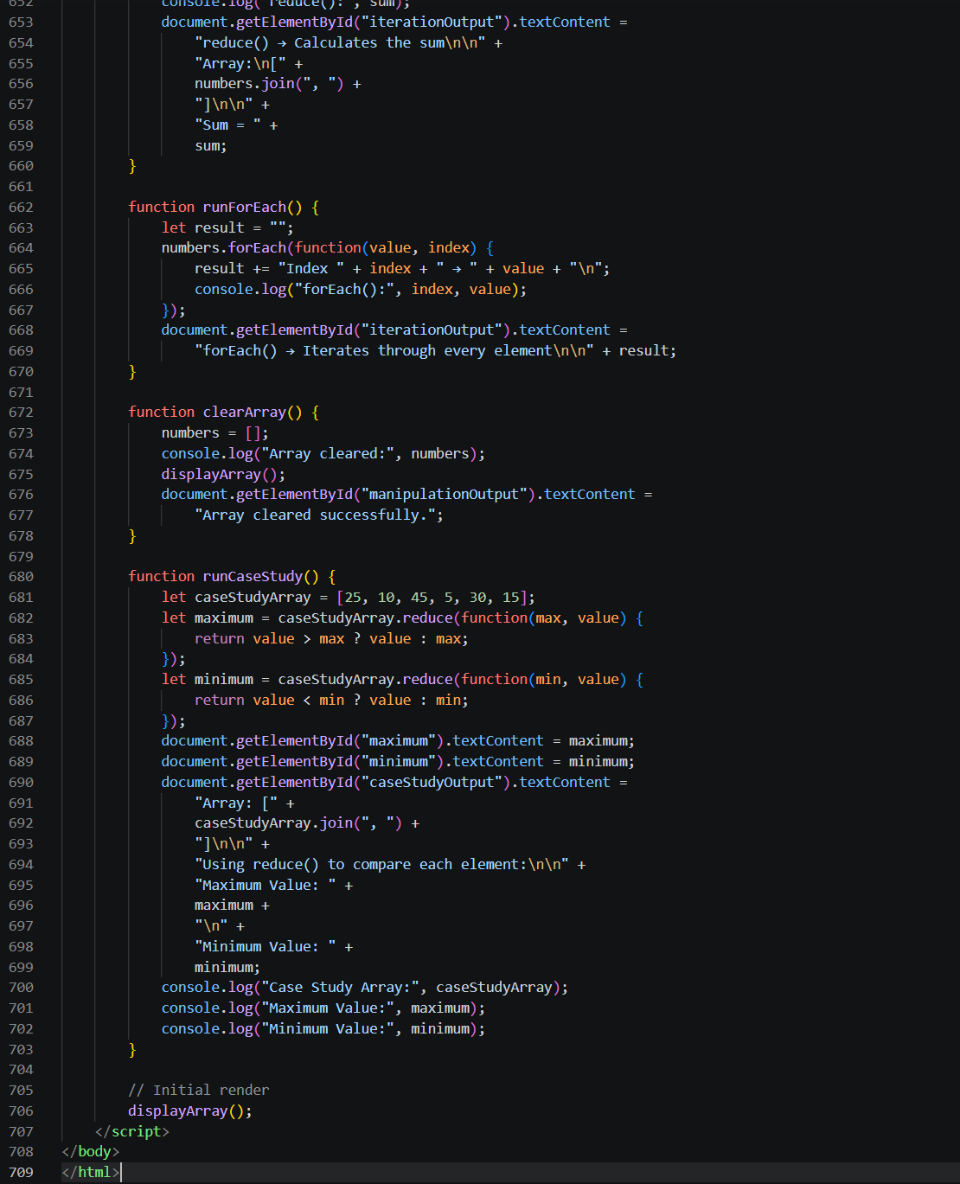

Output:
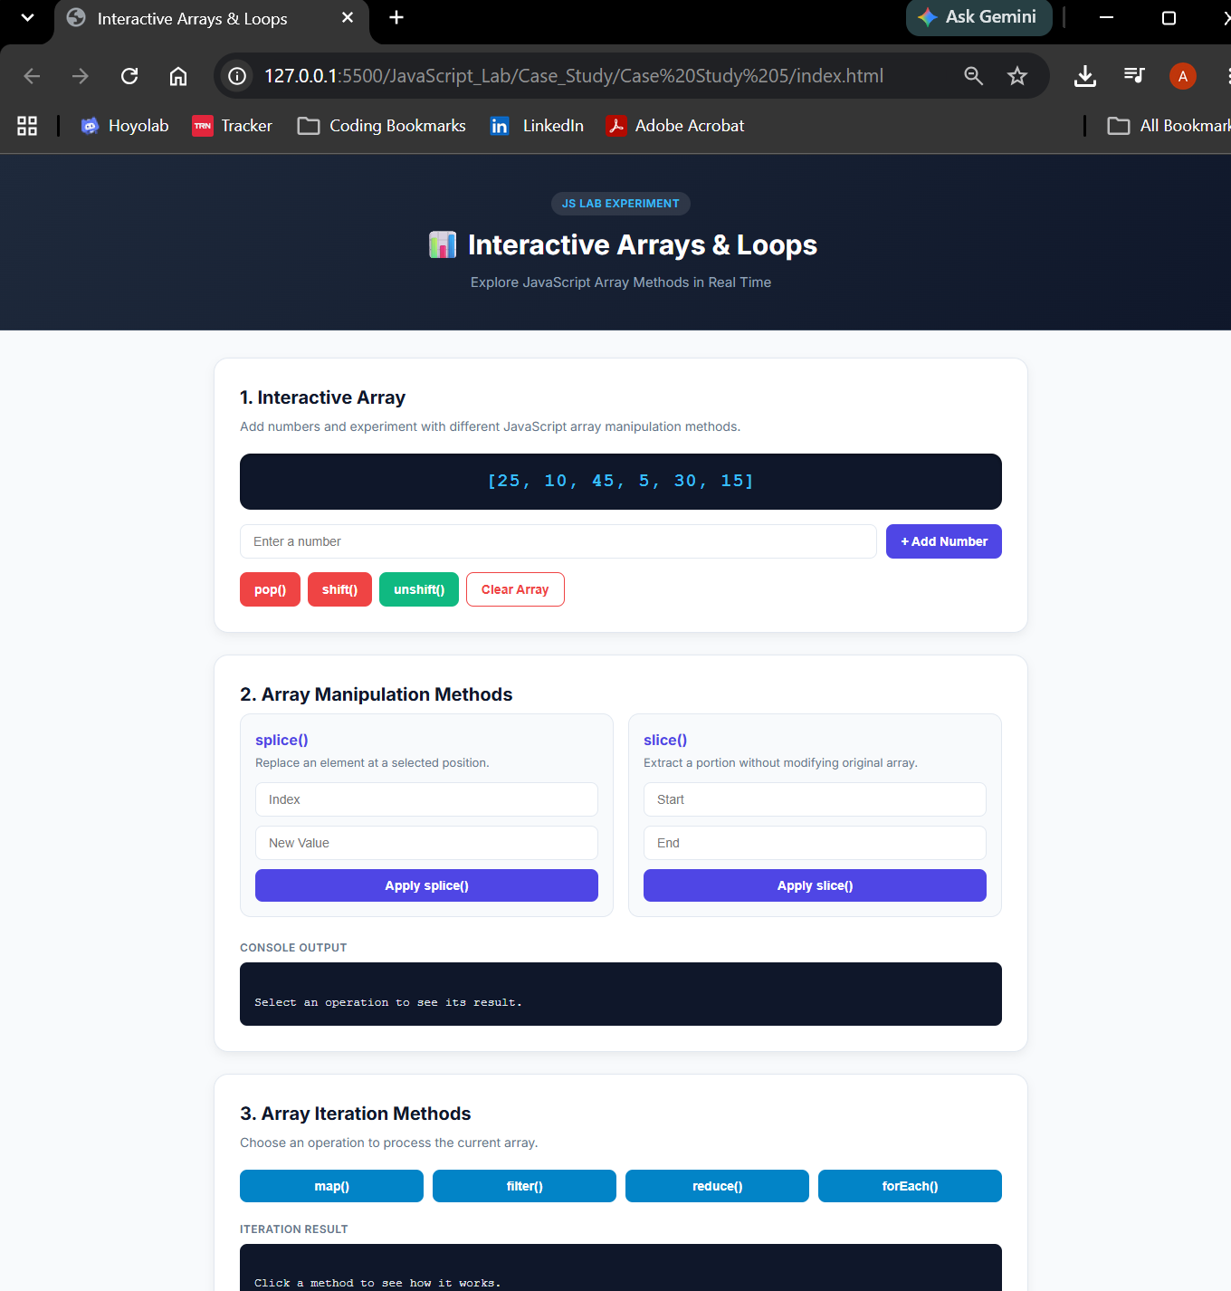

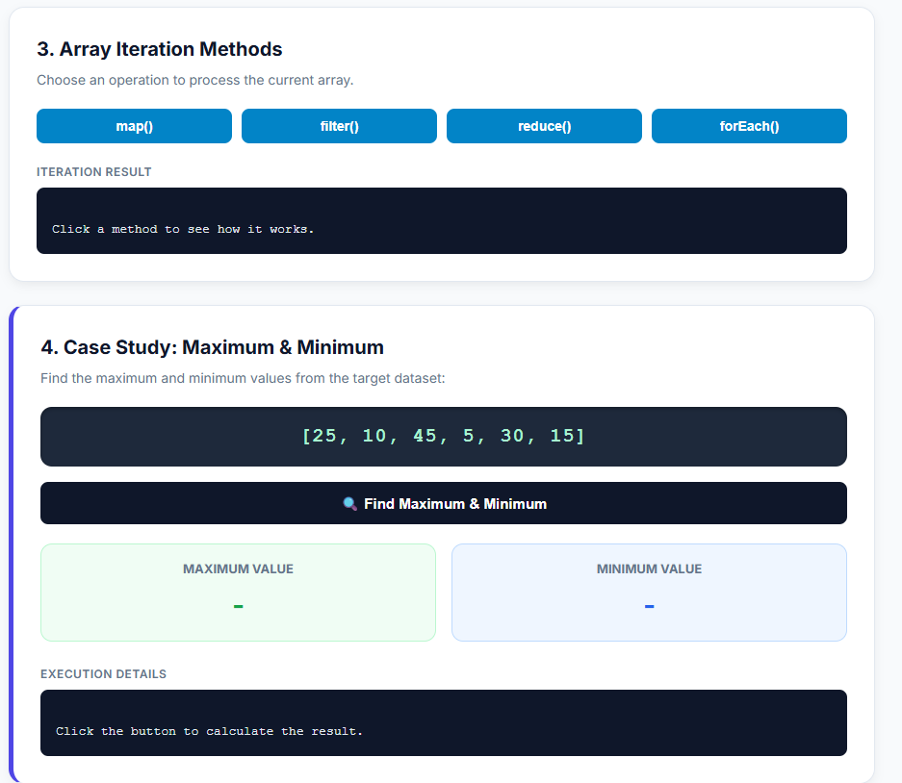

Result: The interactive array and loop demonstration system was successfully implemented and tested. The web interface correctly performs real-time array mutations (push(), pop(), shift(), unshift(), splice(), and slice()) and updates the displayed array dynamically. High-order iteration methods (map(), filter(), reduce(), and forEach()) execute correctly and present their transformed or aggregated outputs in the output console blocks. Additionally, the case study algorithm successfully evaluated the dataset [25, 10, 45, 5, 30, 15] using the .reduce() method, accurately returning 45 as the maximum value and 5 as the minimum value.

Experiment No 6
Aim: Use string function and regex for email validation, data extraction and text analysis
Theory: This practical demonstrates basic web development and text manipulation using HTML, CSS, and JavaScript. The user interface takes string inputs and processes them dynamically in real time using DOM manipulation and standard string methods. Regular Expressions (Regex) are used to search, pattern-match, and extract valid email addresses from unformatted text blocks. Built-in string methods like .toUpperCase(), .toLowerCase(), and .length enable instant case conversion and character counting. Word counts and targeted keyword tracking (e.g., detecting "welcome" and counting "email") are performed by splitting strings and using pattern matching (RegExp.prototype.test() and String.prototype.match()). Overall, the project demonstrates client-side data validation, text processing, and dynamic UI rendering without requiring page reloads.
Outputs:
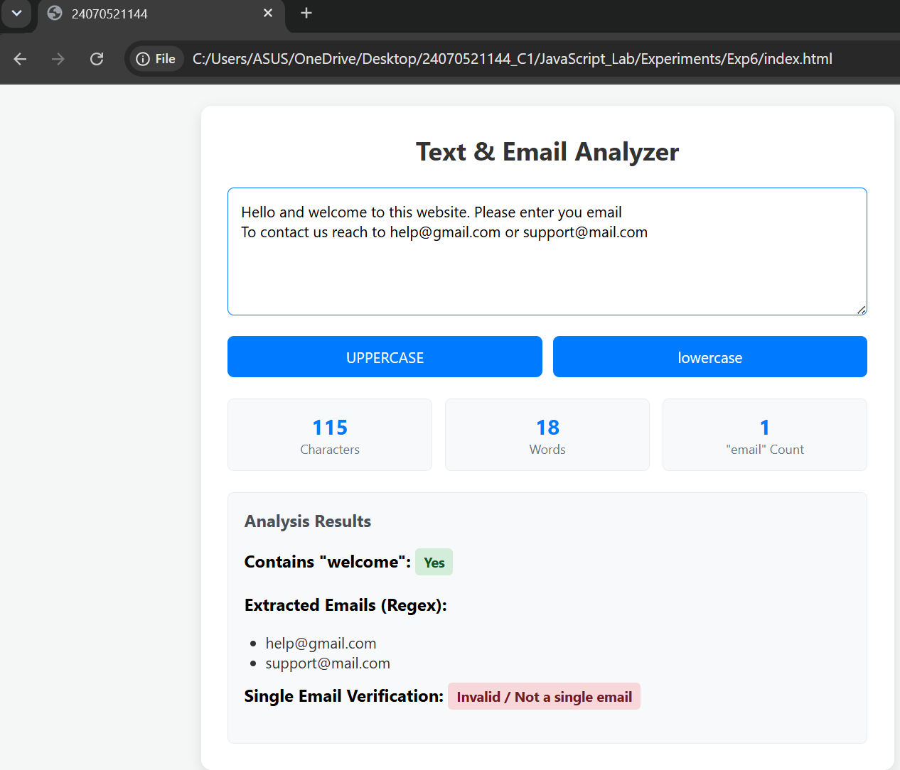

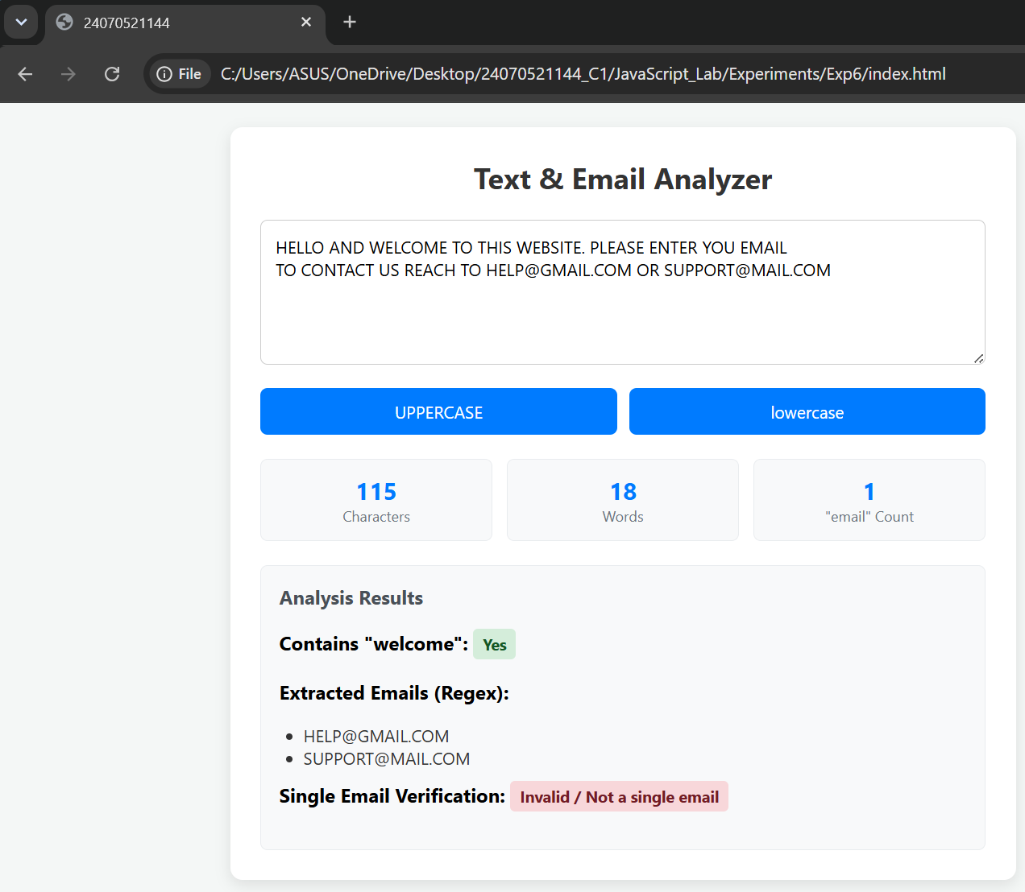
Result:
The developed web application successfully processes user input in real time. It accurately measures total character length and word count, detects the presence of the word "welcome", and counts occurrences of the word "email". Furthermore, the uppercase and lowercase transformation buttons dynamically reformat the text, while the Regular Expression engine correctly extracts all valid email addresses embedded in the text block and validates individual email formats.

Conclusion:
In conclusion, this practical successfully demonstrates the core concepts of client-side web development using HTML, CSS, and JavaScript. By integrating Regular Expressions with DOM manipulation and built-in JavaScript string functions, the application achieves dynamic, real-time text analysis and email validation. This highlights how front-end scripts can manipulate and validate user data instantly without requiring backend server processing or web page reloads.

Case Study 06
Aim:

Program Code:
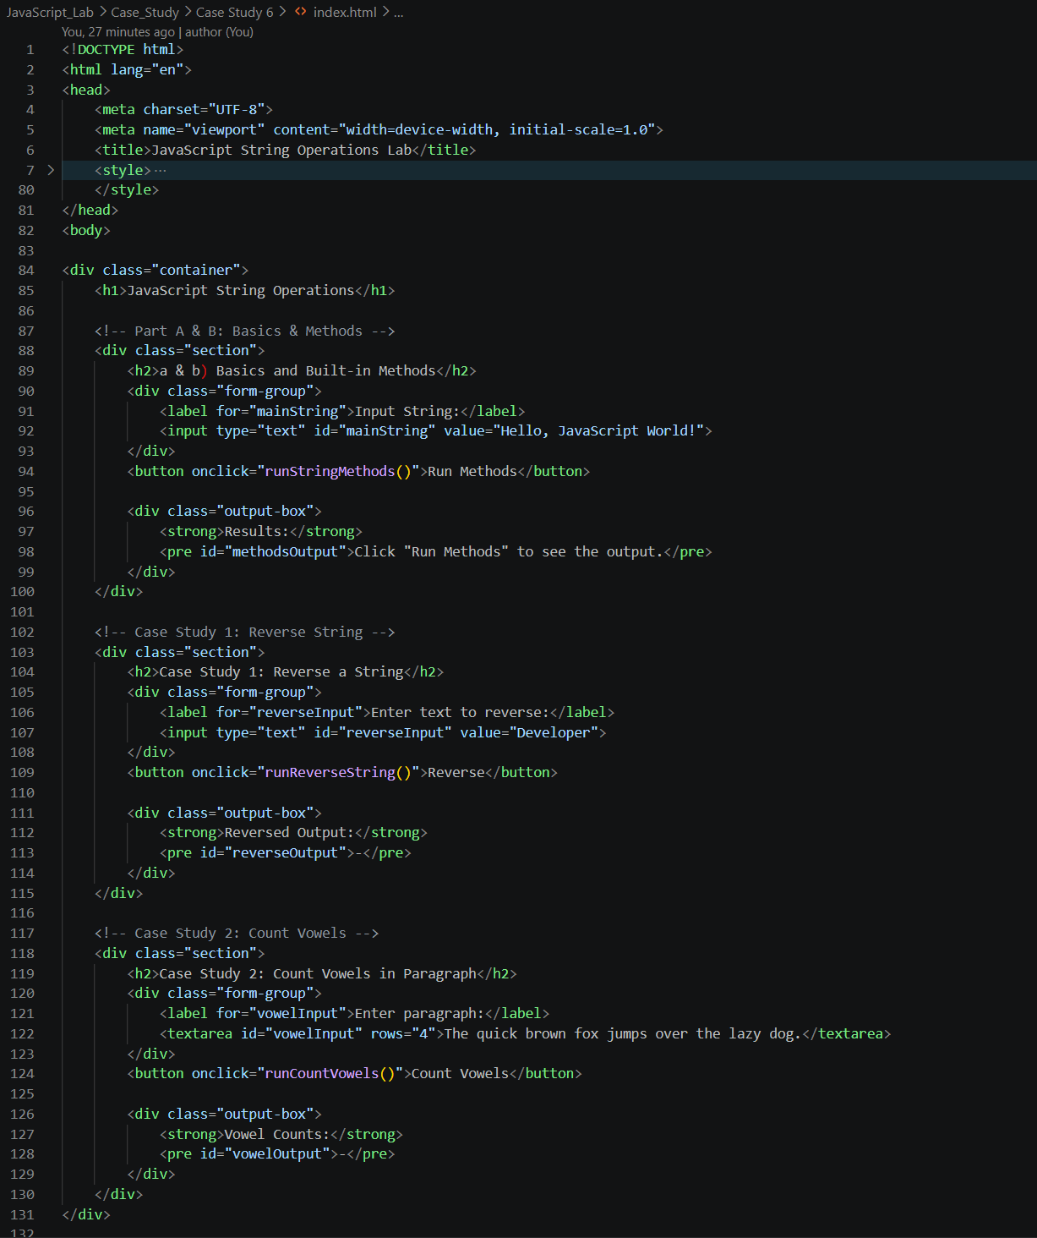
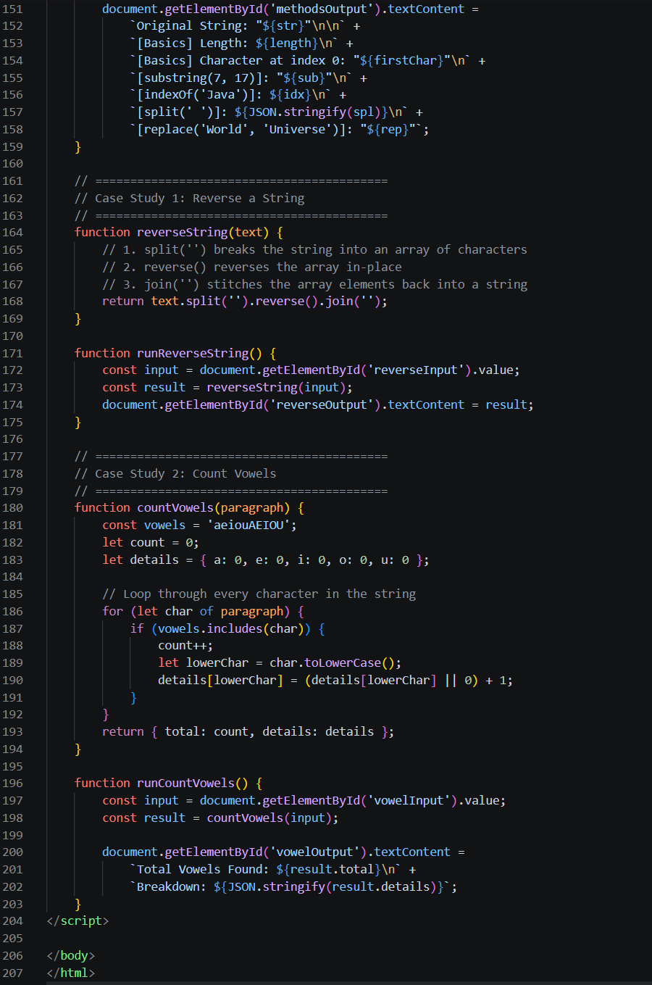
Output:
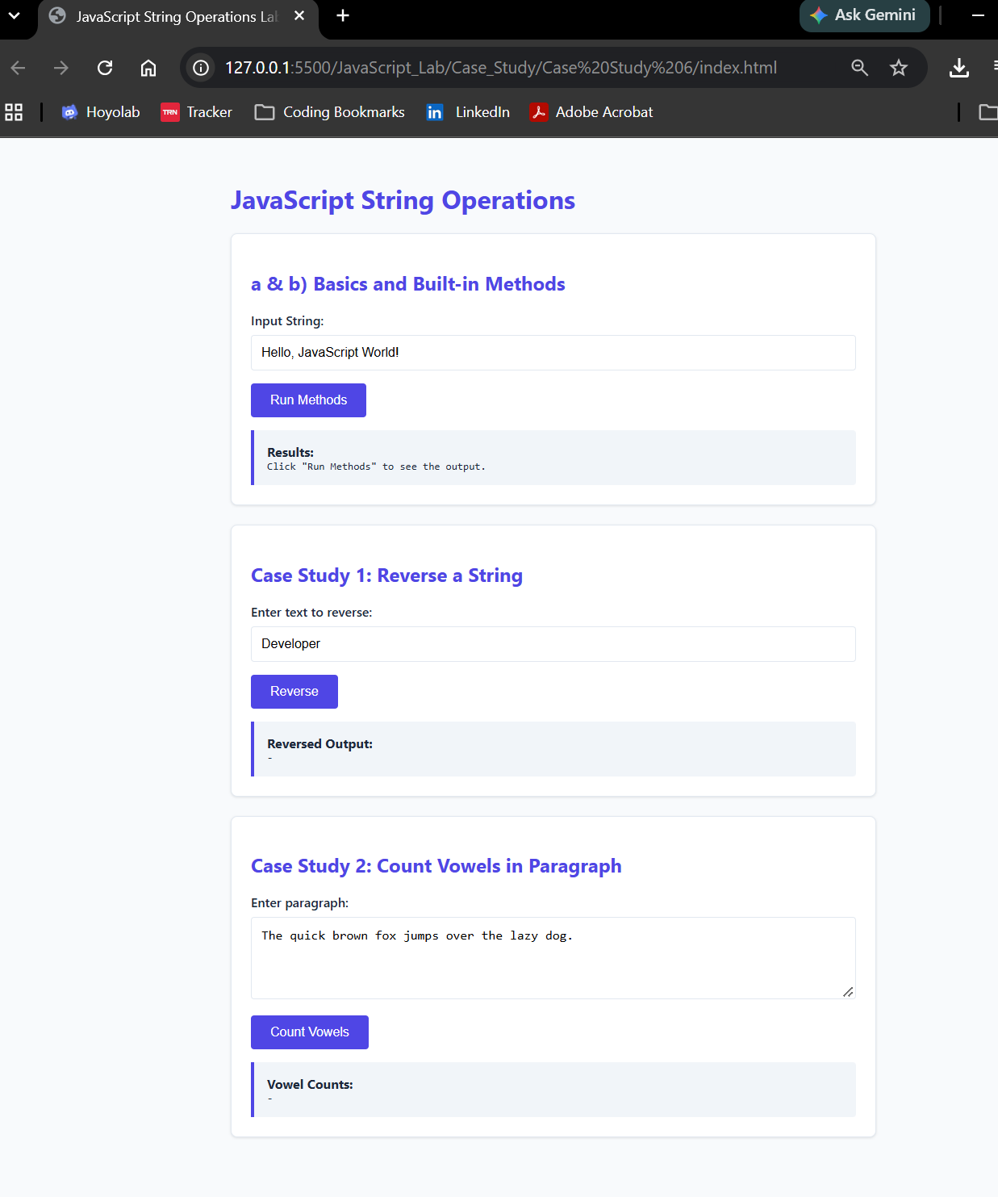
Result:
This experiment demonstrated the effective handling of string data types and manipulation methods in JavaScript. Using built-in methods like .substring(), .split(), and .replace() simplified string searching and parsing without modifying original immutable string variables. Furthermore, combining array techniques and iterative loop checks proved effective for solving practical text processing problems like reversing character sequences and tallying specific target characters.

Experiment 07
Aim: Perform DOM traversal and updates, develop a to-do list app with add, edit and delete features.
Theory:
This practical demonstrates client-side DOM (Document Object Model) manipulation, traversal, and event handling by building a dynamic, interactive To-Do list application. It leverages Event Delegation by attaching single click and change listeners to the parent <ul> container rather than individual ite ms, capturing events as they bubble up from child elements (event.target). Upward DOM traversal is performed using .closest('li') to identify parent task rows, while downward target selection uses .querySelector() to target and mutate descendant nodes. Real-time updates—such as dynamically inserting new elements (appendChild), replacing elements via .innerHTML for inline editing, removing elements with .remove(), and toggling CSS classes for task completion—are achieved smoothly without requiring server calls or page reloads.
Output:
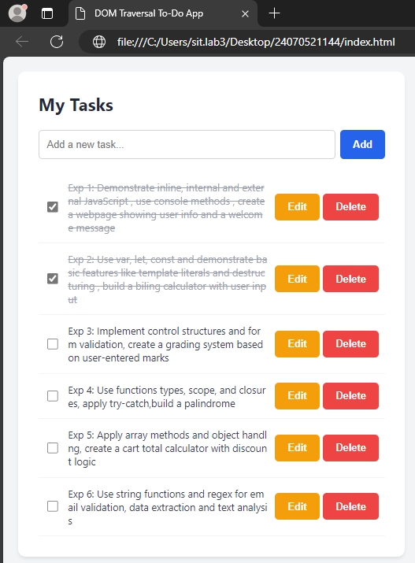

Result:
The To-Do application successfully performs real-time client-side task management with full CRUD capability without requiring page reloads. Users can dynamically generate new task items, edit existing task text through an inline input field, delete items instantly from the DOM tree, and toggle completion states via checkboxes to visually strike through finished tasks.
Conclusion:
In conclusion, this project effectively validates the core principles of front-end JavaScript DOM manipulation, traversal, and event handling. By utilizing event delegation on a single parent element and targeting relative nodes using Element.closest() and Element.querySelector(), the application maintains high performance, clean memory management, and smooth interactive updates for dynamically generated elements.

Case Study 07
Aim: To demonstrate the events handling in javascript
a)Access and manipulate form elements using js.
b) Validate user inputs(e.g. Email, empty fields).
c) Use various form events (submit,change,focus)
Create the following html form and use required js and events in a given form (first name, last name, email, birthday, password, reenter password, agree to the terms and conditions)
Program Code:
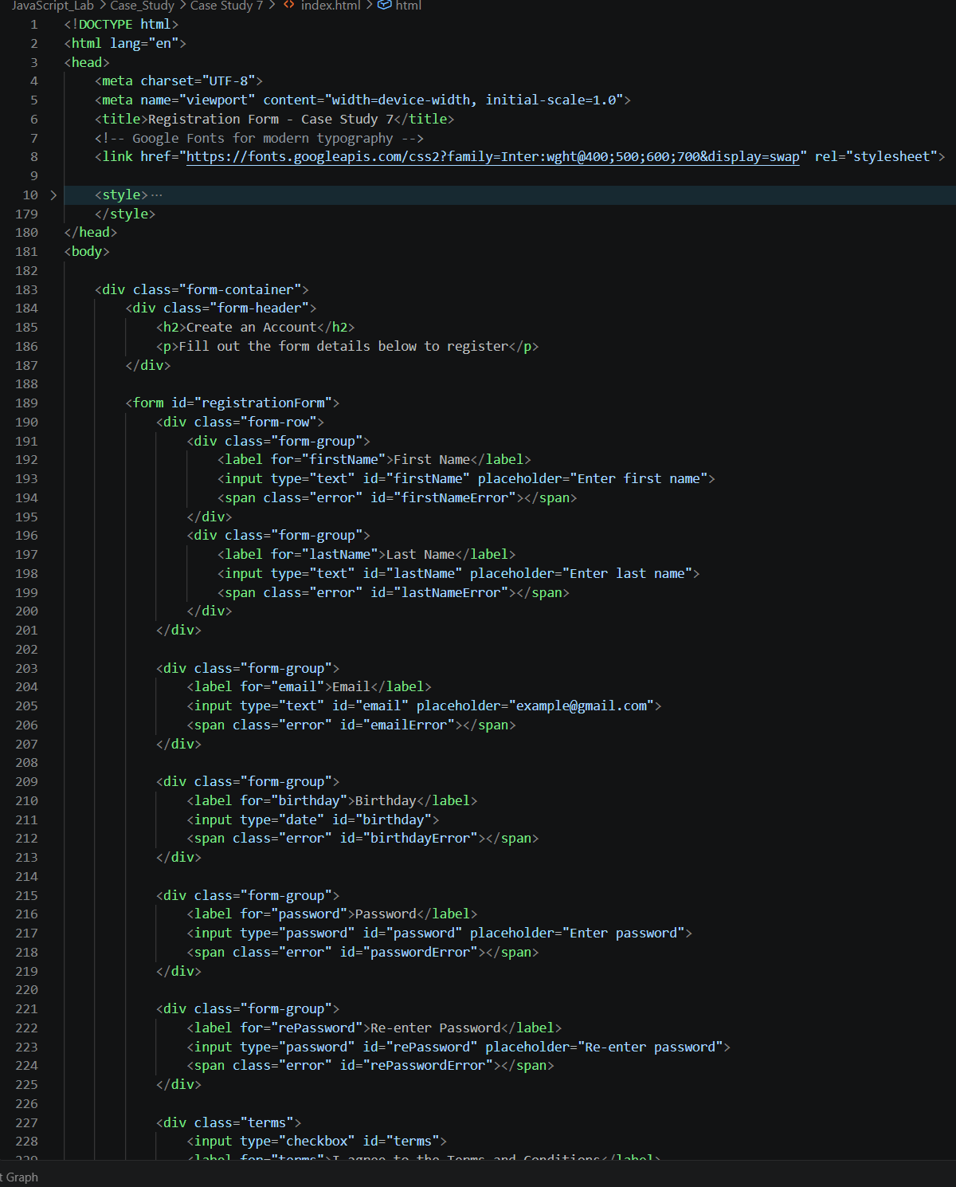
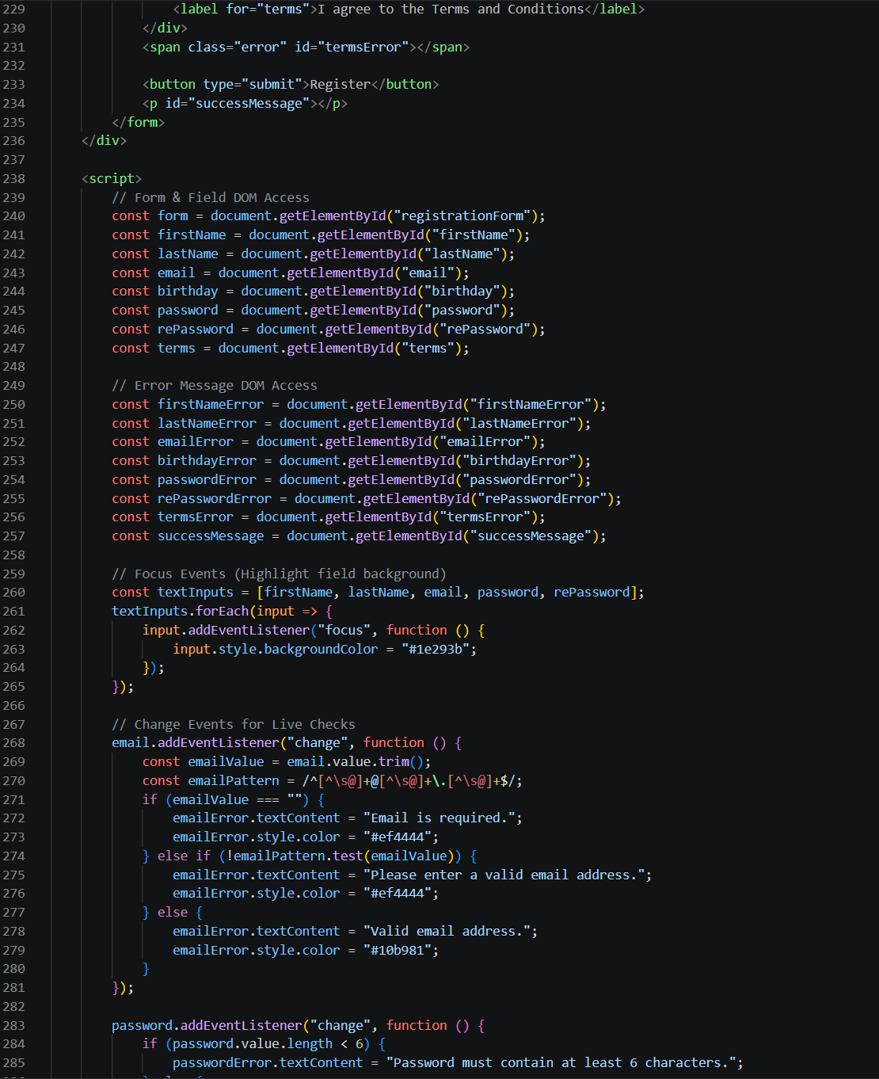

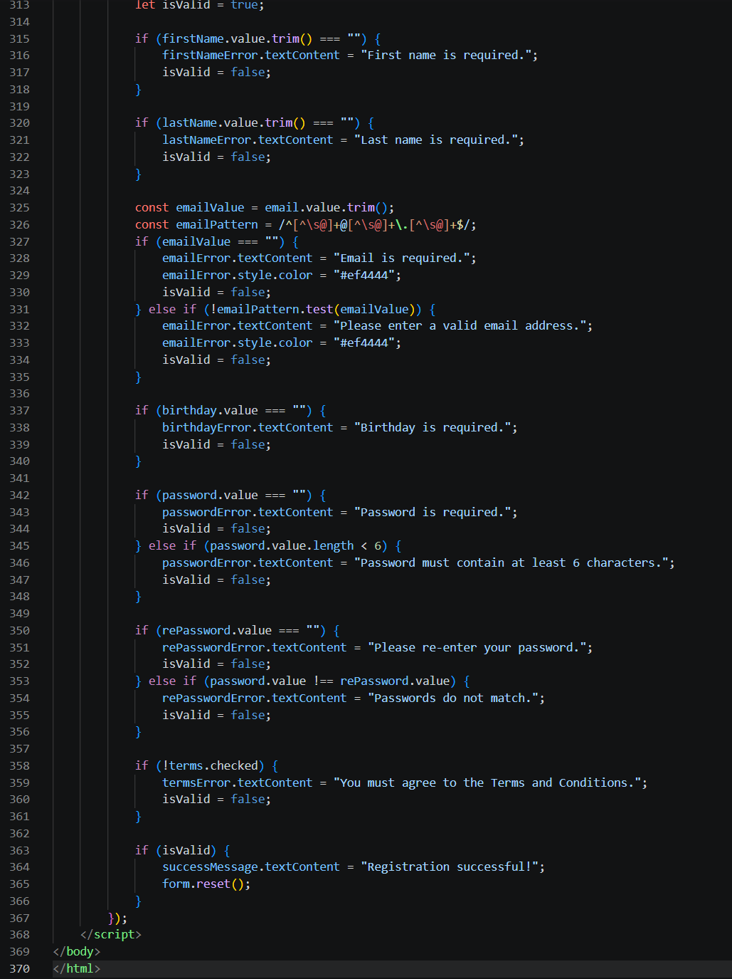

Output:
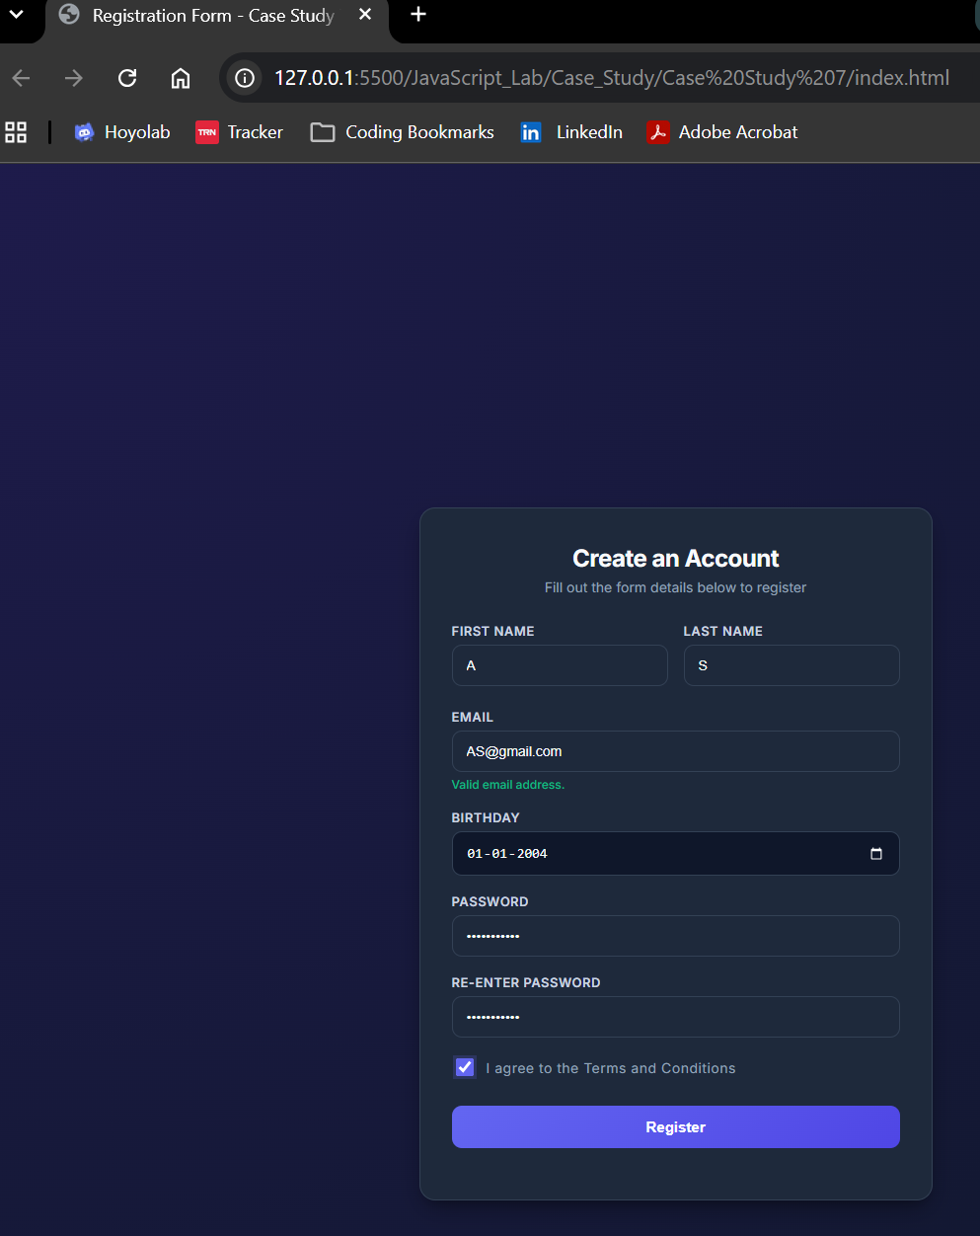
Result:
The registration form was successfully created with JavaScript event handling and input validation for email, password, required fields, and terms acceptance. The application dynamically processes user focus and input changes, provides instant error feedback, and confirms completion with a "Registration successful!" message upon valid submission.

Experiment 08
Aim: Access and validate form fields using events. Design a gym admission form with live input checks.
Theory:
JavaScript event listeners enable interactive, real-time user validation by monitoring form events such as input (triggers on every keystroke) and change (triggers when a selection changes). By attaching listeners to input elements, JavaScript can intercept user inputs immediately, apply regular expression pattern checks or boundary logic, and provide instant visual feedback. Accessing DOM element values directly using document.getElementById() allows developers to validate data client-side before form submission. This approach prevents invalid submissions, improves data accuracy, and creates a responsive user experience by giving instant feedback without full-page reloads.

Output:
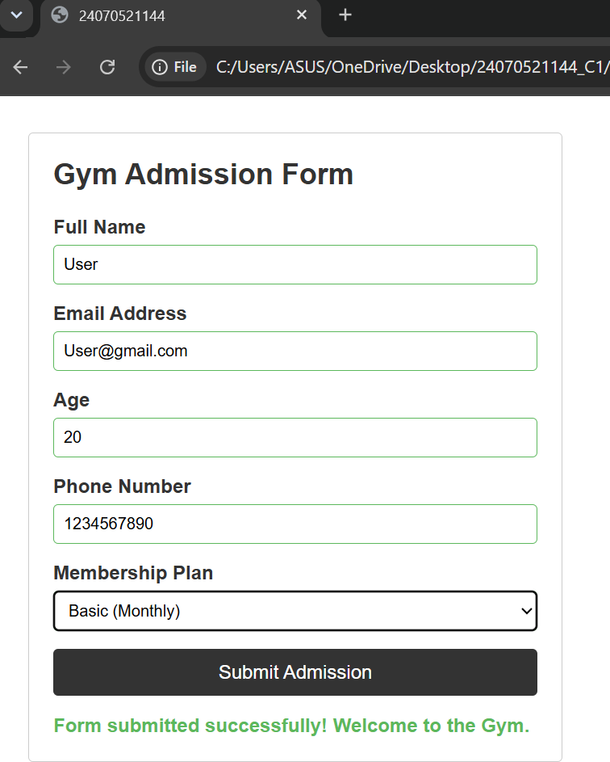

Result:
The Gym Admission Form with live input checks was successfully built using HTML, CSS, and JavaScript event handlers. The application continuously monitors user actions across five fields (Full Name, Email Address, Age, Phone Number, and Membership Plan). Real-time validation correctly highlights input borders green for valid entries and red for errors, displays instant contextual error messages, and keeps the submission button disabled until all constraints are met.
Conclusion:
This experiment demonstrated the practical implementation of DOM field access and event-driven form validation in JavaScript. Using real-time event listeners (input and change) proved significantly more user-friendly than traditional form submission checks. Client-side input validation effectively ensures data integrity, improves application responsiveness, and eliminates invalid form submissions prior to server processing.

Case Study 08
Aim:

Program Code:
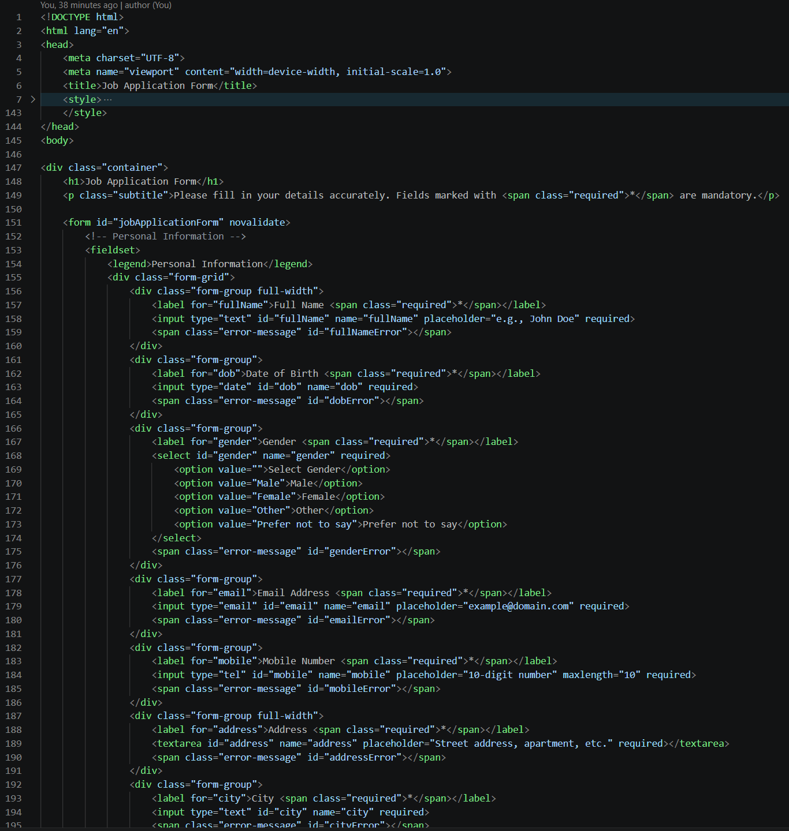

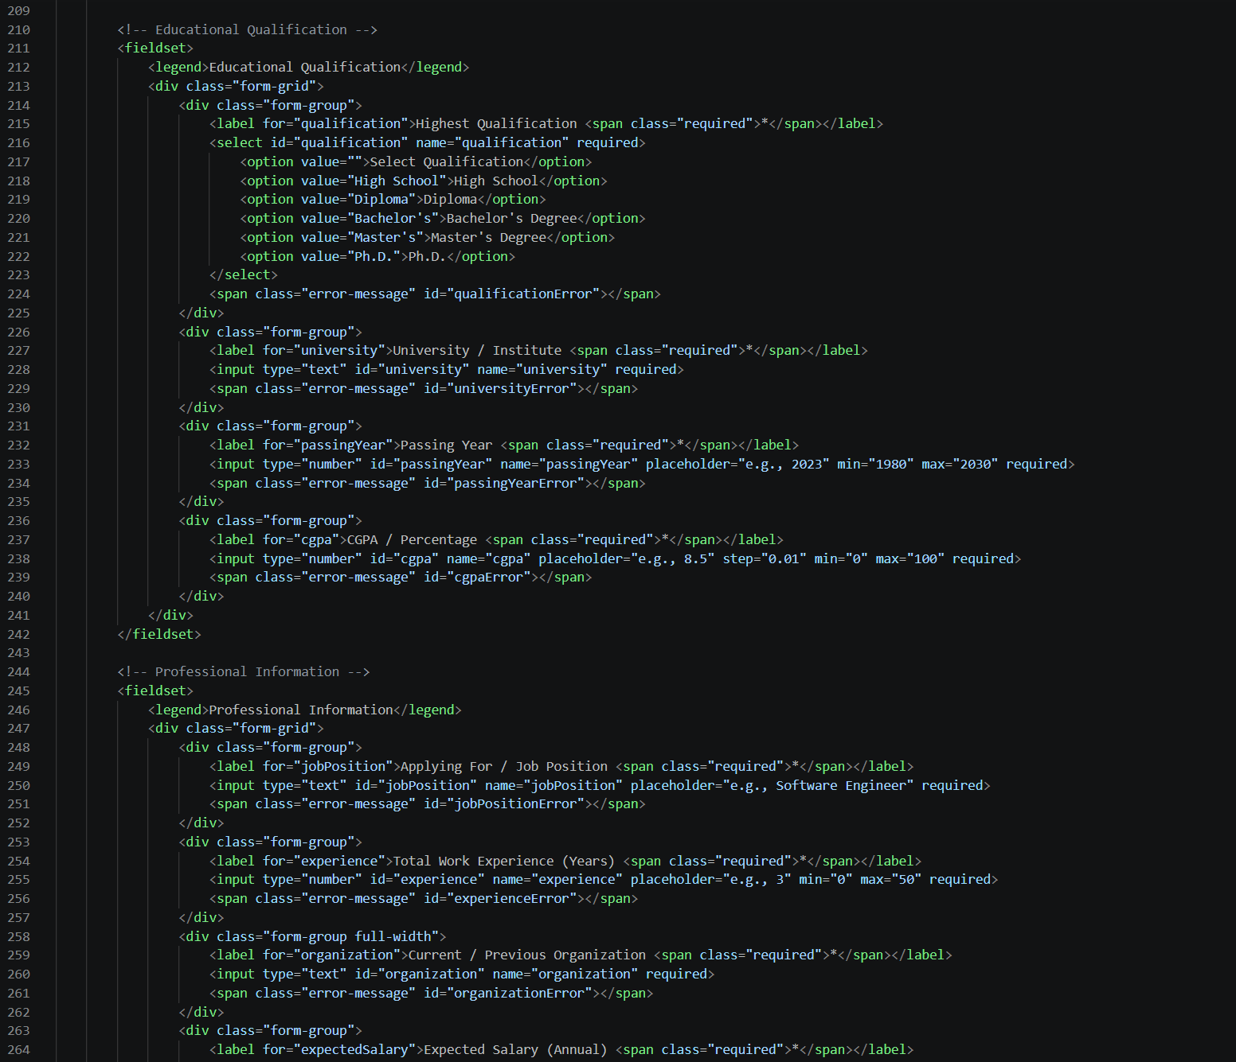
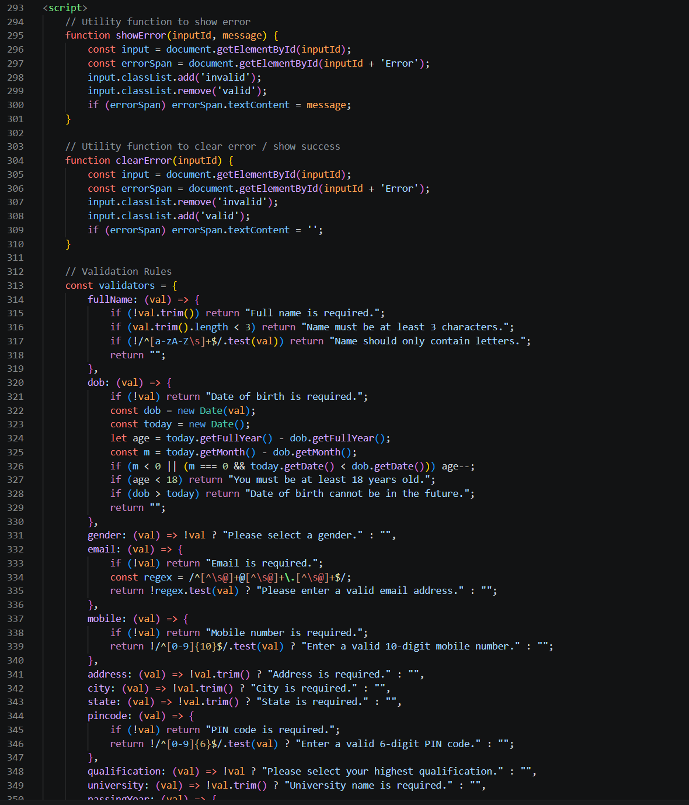

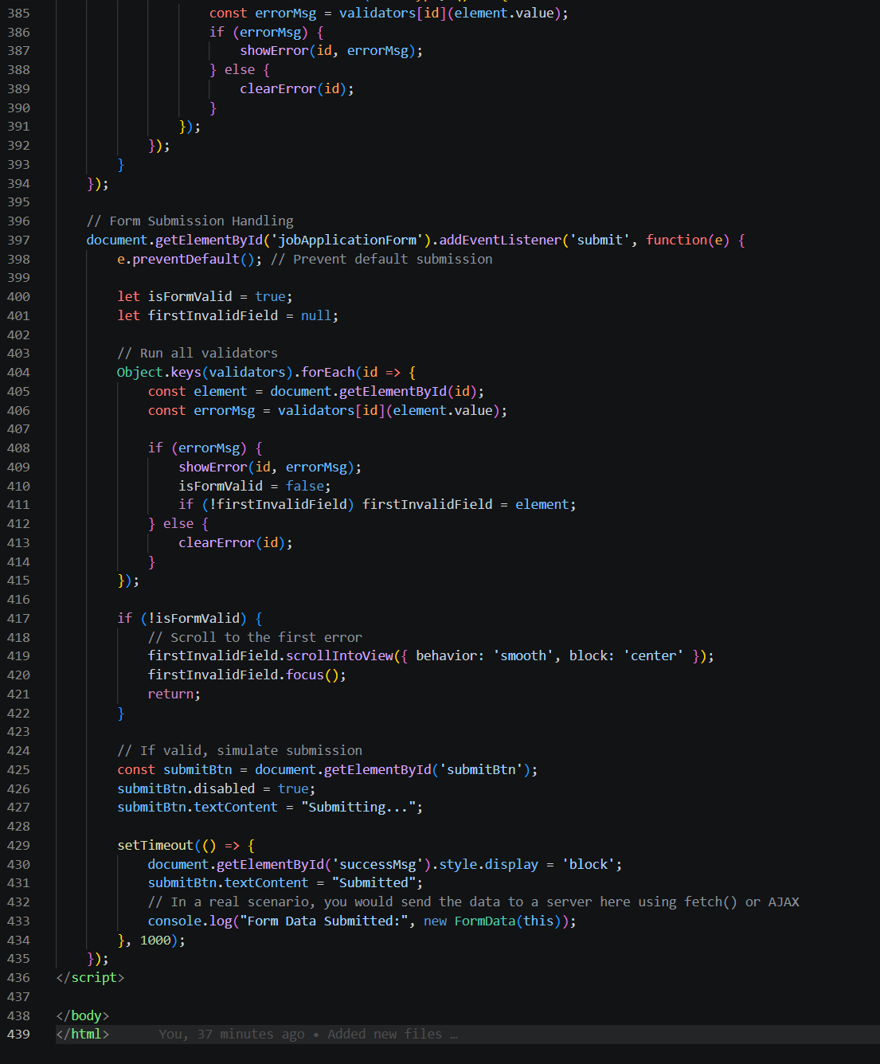

Output:
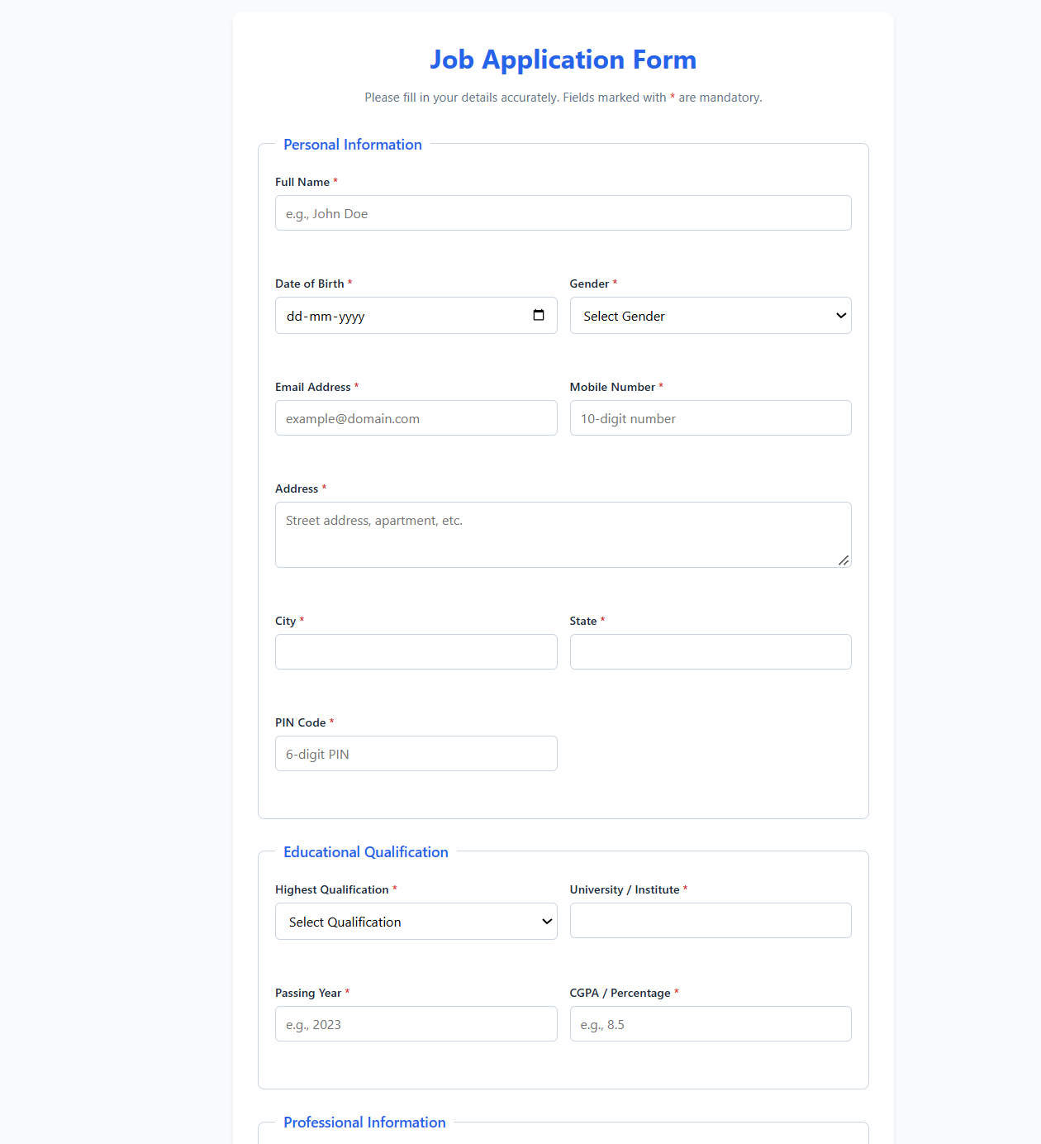



Result: This experiment demonstrated the end-to-end design and implementation of client-side form validation for a complex multi-section application form. Centralizing validation logic inside a structured JavaScript validators lookup object streamlined real-time input checks and DOM manipulation. Utilizing event-driven validation improves user feedback, preserves data integrity prior to form submission, and ensures a responsive user experience.

Experiment 09
Aim: Implement Local and Session storage to save user preferences like theme settings
Theory:
Web Storage API provides key-value storage mechanisms—localStorage and sessionStorage—that allow web applications to store data locally within the user's browser without sending it to a server. localStorage persists data permanently across browser sessions until explicitly cleared, making it ideal for storing long-term user preferences such as theme settings (dark/light mode). sessionStorage, on the other hand, maintains data only for the duration of the current page session and clears automatically when the browser tab or window closes. Data in Web Storage is stored as strings, requiring getItem(), setItem(), and removeItem() methods for manipulation. In this experiment, these storage mechanisms are implemented to save, retrieve, and automatically apply a user's selected theme preferences across page reloads and browser sessions.

Output:
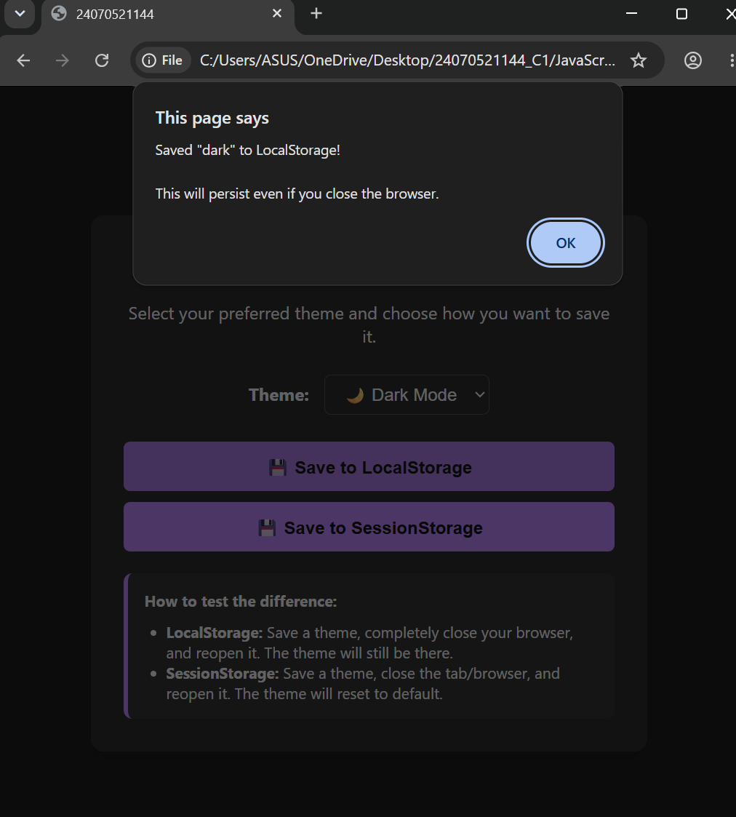

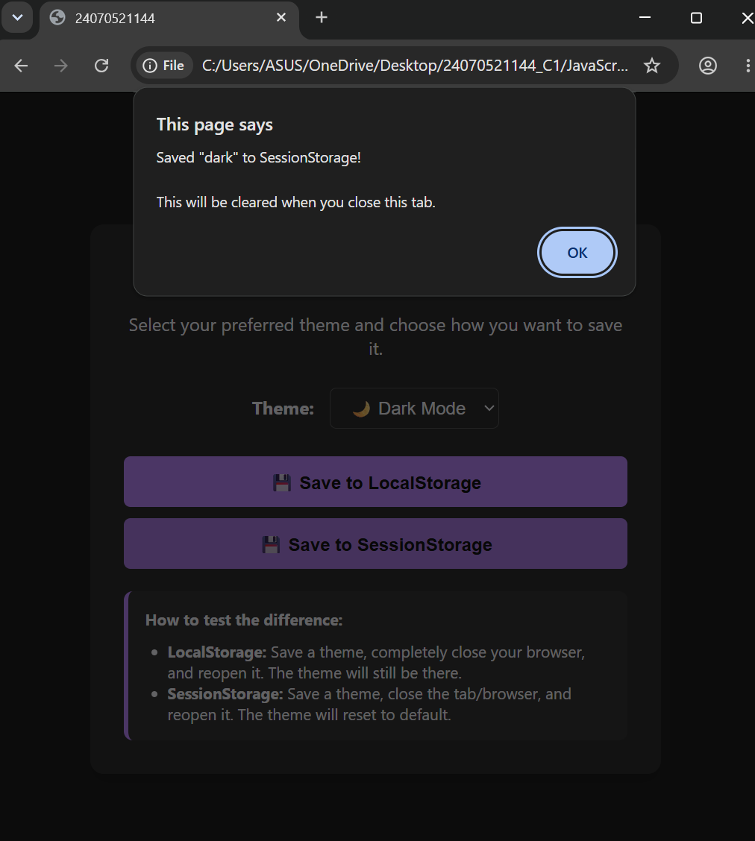

Result: The theme preference manager was successfully implemented using localStorage and sessionStorage. The application accurately captures user input (such as toggling between light and dark themes), saves the selected state in the browser's web storage, and applies the preferred theme instantly via DOM manipulation. Upon reloading the page or reopening the tab, the application successfully retrieves the saved preference from storage and maintains the correct theme without manual reselection.
Conclusion: This experiment demonstrated the practical usage of the Web Storage API for managing client-side state and user preferences. Utilizing localStorage proved effective for maintaining persistent application states like theme modes across browser restarts, while sessionStorage demonstrated its utility for tab-bound temporary data. Implementing client-side storage reduces unnecessary server requests, speeds up initial page styling on load, and enhances overall user experience through persistent personalization.`

Experiment 10
Aim: Load and display JSON data using fetch() and jQuery$.getJSON(), render results dynamically in a table
Theory:
The JavaScript Fetch API and jQuery library provide robust asynchronous methods for retrieving and rendering structured data (such as JSON) dynamically on web pages without triggering a full page reload. Local JSON arrays allow client-side modeling of structured records, which can be queried asynchronously using JavaScript Promises or jQuery helper methods ($.each()). When data is fetched, DOM manipulation techniques iterate through the array to generate dynamic HTML table elements (<tr> and <td>), replacing static placeholders. Furthermore, integrating user feedback mechanisms—such as dynamic status text and loading indicators—ensures an asynchronous user experience by signaling data processing states during execution.
Output:
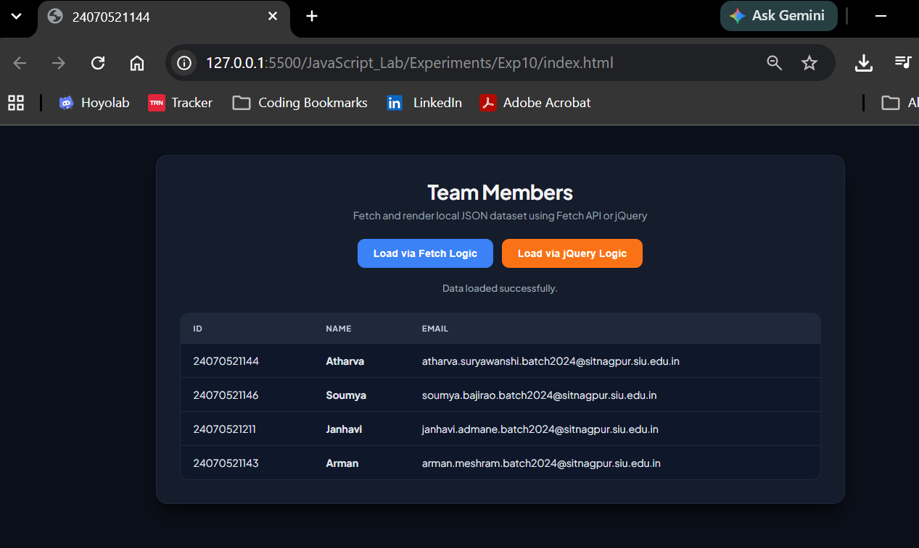

Result: The Local JSON Data Table application was successfully built and tested using both native JavaScript Fetch logic (simulated using Promises) and jQuery array iteration methods. Upon clicking either the "Load via Fetch Logic" or "Load via jQuery Logic" button, the application triggers a loading animation and updates the status message to indicate processing. After an artificial delay simulating a network request, the local JSON team dataset—containing member ID numbers, names, and official institutional email addresses—is dynamically parsed and injected into the target HTML table. Both methods consistently generated identical table structures, updated the status text to confirm successful data loading, and hid the loader once rendering was complete.
Conclusion: This experiment demonstrated the practical implementation of client-side data rendering using JavaScript Promises and jQuery. Simulating asynchronous retrieval highlighted how modern Web APIs and JS libraries process structured JSON data to dynamically update DOM elements without refreshing the web page. Both the Fetch API logic and jQuery methods proved effective for handling local data arrays, ensuring efficient data presentation and a seamless, responsive user interface.

